UNITED STATES

SECURITIES AND EXCHANGE COMMISSION

Washington, D.C. 20549

______________

FORM 8-K

______________

Current Report

Pursuant to Section 13 OR 15(d) of the Securities Exchange Act of 1934

Date of Report (Date of earliest event reported): May 11, 2026 (May 6, 2026)

______________

MOLINA HEALTHCARE, INC.

(Exact name of registrant as specified in its charter)

Delaware | 1-31719 | 13-4204626
(State or other jurisdiction of | (Commission File Number) | (IRS Employer Identification No.)
incorporation) | (Commission File Number) | (IRS Employer Identification No.)
 | ______________
200 Oceangate, Suite 100, Long Beach, California |  | 90802
(Address of principal executive offices) |  | (Zip Code)

Registrant’s telephone number, including area code: (562) 435-3666

N/A

(Former name or former address, if changed since last report.)

Check the appropriate box below if the Form 8-K filing is intended to simultaneously satisfy the filing obligation of the registrant under any of the following provisions:

- Written communications pursuant to Rule 425 under the Securities Act (17 CFR 230.425)

- Soliciting material pursuant to Rule 14a-12 under the Exchange Act (17 CFR 240.14a-12)

- Pre-commencement communications pursuant to Rule 14d-2(b) under the Exchange Act (17 CFR 240.14d-2(b))

- Pre-commencement communications pursuant to Rule 13e-4(c) under the Exchange Act (17 CFR 240.13e-4(c)) Securities registered pursuant to Section 12(b) of the Act:
Title of each class | Trading Symbol(s) | Name of each exchange on which registered
Common Stock, $0.001 Par Value | MOH | New York Stock Exchange

Indicate by check mark whether the registrant is an emerging growth company as defined in Rule 405 of the Securities Act of 1933 (§230.405 of this chapter) or Rule 12b-2 of the Securities Exchange Act of 1934 (§240.12b-2 of this chapter).

 | Emerging growth company | ☐
 | If an emerging growth company, indicate by check mark if the registrant has elected not to use the extended transition period for complying with any new or revised financial | ☐
 | accounting standards provided pursuant to Section 13(a) of the Exchange Act. | ☐

Item 5.02. Departure of Directors or Certain Officers; Election of Directors; Appointment of Certain Officers; Compensatory Arrangements of Certain Officers.

At the 2026 Annual Meeting of Stockholders (the “Annual Meeting”) of Molina Healthcare, Inc. (the “Company”) held on May 6, 2026, as further described in Item 5.07 below, the Company’s stockholders approved an amendment to the Company’s 2025 Equity Incentive Plan (the “2025 Plan Amendment”) to, increase the aggregate number of shares of the Company’s common stock authorized for issuance thereunder by 1,500,000 shares to 3,295,000 shares. The 2025 Plan Amendment previously had been approved, subject to stockholder approval, by the Company's Board of Directors.

A summary of the material terms of the 2025 Plan Amendment is set forth in “Proposal 4, Approval of the Amendment to the Molina Healthcare, Inc. 2025 Equity Incentive Plan” in the Company’s definitive proxy statement for the Annual Meeting (the “Proxy Statement”) filed with the Securities and Exchange Commission on March 23, 2026, which description is incorporation herein by reference. That summary and the foregoing description of the 2025 Plan Amendment are qualified in their entirety by reference to the text of the 2025 Plan Amendment, a copy of which is filed as Exhibit 10.1 hereto and incorporated herein by reference

Item 5.03. Amendments to Articles of Incorporation or Bylaws; Change in Fiscal Year.

On May 6, 2026, at the Annual Meeting, as further described in Item 5.07 below, the Company’s stockholders approved an amendment to the Company’s Amended and Restated Certificate of Incorporation to allow stockholders holding at least 20% of the voting power of the outstanding shares of capital stock of the Company to call a special meeting of stockholders, subject to the requirements and procedures set forth in the Company’s Amended and Restated Bylaws, as now or hereinafter in effect (the “Special Meeting Amendment”).

Following the Annual Meeting, on May 6, 2026, the Company filed a Certificate of Amendment with the Secretary of State of the State of Delaware, at which point the Special Meeting Amendment became effective.

In addition, on May 6, 2026, the Company’s Board of Directors (the “Board”) approved and adopted an amendment and restatement of the Company’s Amended and Restated Bylaws (as so amended and restated, the “Amended and Restated Bylaws”), effective immediately. Among other things, the amendments contained in the Amended and Restated Bylaws provide for the following:

- Requesting stockholder(s) must demonstrate that they own and have held continuously for at least one (1) year an aggregate of at least 20% of the voting power of the outstanding shares of capital stock of the Company.

- Requesting stockholder(s) must provide, among other things, the same information currently required by our Bylaws’ advance notice provisions.

- A special meeting request will not be valid if, among other things:

  - The requesting stockholder(s) do(es) not satisfy the applicable procedural and disclosure requirements;

  - the business requested to be transacted at such meeting is not a proper subject for stockholder action under applicable law;

  - the business proposed to be conducted at the meeting (other than the election of directors) is identical or substantially similar to an item of business (a “Similar Item”) for which a record date was previously fixed, and the request is delivered between the 61st day after and the one-year anniversary of such record date;

  - a Similar Item was covered at the most recent annual meeting or at a special meeting held within one year prior to the date on which the request was received;

  - a Similar Item of business is to be covered at a stockholder meeting called by the Board to be held within 90 days after the request is received; or

  - a Similar Item has been presented at the most recent annual meeting of stockholders or at any special meeting of stockholders held within one year prior to receipt of the request.

The Amended and Restated Bylaws also incorporate certain technical, modernizing, clarifying and conforming changes.

The foregoing descriptions of the Special Meeting Amendment and the Amended and Restated Bylaws do not purport to be complete and are qualified in their entirety by reference to the full text of the Certificate of Amendment and Amended and Restated Bylaws, as applicable, which are attached hereto as Exhibits 3.1 and 3.2, respectively, and incorporated herein by reference.

Item 5.07. Submission of Matters to a Vote of Security Holders.

On May 6, 2026, the Company held its Annual Meeting. As of the close of business on March 9, 2026 (the “Record Date”), a total of 52,091,073 shares of the Company’s common stock (the “Common Stock”) were issued and outstanding. At the Annual Meeting, holders of 47,172,628 shares of Common Stock, or 90.55% of shares outstanding on the Record Date, were represented in person or by proxy, constituting a quorum. All director nominees were duly elected, and all proposals were approved by stockholders.

With regard to Proposal No. 1, for the election of the ten directors named below to hold office until the 2027 annual meeting, the stockholders voted as follows:

Director | Votes For | Votes Against | Abstentions | Broker
 |  |  |  | Non-Votes
Barbara L. Brasier | 41,403,098 | 1,173,580 | 50,838 | 4,545,112
Leo P. Grohowski | 41,418,155 | 1,159,784 | 49,577 | 4,545,112
Stephen H. Lockhart | 42,374,279 | 205,101 | 48,136 | 4,545,112
Steven J. Orlando | 40,955,995 | 1,620,889 | 50,632 | 4,545,112
Ronna E. Romney | 38,461,391 | 4,035,124 | 131,001 | 4,545,112
Richard M. Schapiro | 42,174,723 | 403,527 | 49,266 | 4,545,112
Francis S. Soistman | 42,371,936 | 199,759 | 55,821 | 4,545,112
Dale B. Wolf | 39,097,714 | 3,479,902 | 49,900 | 4,545,112
Richard C. Zoretic | 42,369,441 | 210,513 | 47,562 | 4,545,112
Joseph M. Zubretsky | 42,327,641 | 277,647 | 22,228 | 4,545,112

With regard to Proposal No. 2, for the approval, on a non-binding, advisory basis, of the compensation of the Company’s named executive officers, the stockholders voted as follows:

Votes For | Votes Against | Abstentions | Broker Non-Votes
22,459,321 | 20,116,888 | 51,307 | 4,545,112

With regard to Proposal No. 3, for the ratification of the appointment of Ernst & Young LLP as the Company’s independent registered public accounting firm for 2026, the stockholders voted as follows:

Votes For

45,850,249

Votes Against

1,293,650

Abstentions

28,729

Broker Non-Votes

0

With regard to Proposal No. 4, for the approval of an amendment to the Company’s 2025 Equity Incentive Plan to increase the number of shares available for issuance under such plan, the stockholders voted as follows:

Votes For

31,318,146

Votes Against

11,285,569

Abstentions

23,801

Broker Non-Votes

4,545,112

With regard to Proposal No. 5, for the approval of an amendment to the Company’s Certificate of Incorporation to permit stockholders to call special stockholders meetings, the stockholders voted as follows:

Votes For

42,570,475

Votes Against

42,704

Abstentions

14,337

Broker Non-Votes

4,545,112

Item 9.01. Financial Statements and Exhibits.

- Exhibits:

Exhibit No. | Description
3.1 | Certificate of Amendment to Certificate of Incorporation
3.2 | Amended and Restated Bylaws of Molina Healthcare, Inc.
10.1 | Amendment Number One to the Molina Healthcare, Inc. 2025 Equity Incentive Plan
104 | Cover Page Interactive Data File (embedded within the Inline XBRL document)

SIGNATURE

Pursuant to the requirements of the Securities Exchange Act of 1934, the registrant has duly caused this report to be signed on its behalf by the undersigned hereunto duly authorized.

 |  | MOLINA HEALTHCARE, INC.
Date: | May 11, 2026 | By: | /s/ Jeff D. Barlow
 |  |  | Jeff D. Barlow
 |  |  | Chief Legal Officer and Secretary

CERTIFICATE OF AMENDMENT TO THE

CERTIFICATE OF INCORPORATION

OF

MOLINA HEALTHCARE, INC.

Pursuant to §242 of the General Corporation Law

of the State of Delaware

Molina Healthcare, Inc. (the “Corporation”), a corporation organized and existing under and by virtue of the General Corporation Law of the State of Delaware,

DOES HEREBY CERTIFY THAT:

- The Board of Directors of the Corporation duly adopted resolutions at a meeting recommending and declaring advisable that the Certificate of Incorporation of the Corporation be amended, and that such amendment be submitted to the stockholders of the Corporation for their consideration, as follows:

RESOLVED, that Article X, Paragraph A of the Certificate is hereby amended and restated in its entirety to read as follows:

“Special meetings of the stockholders of the Corporation for any purpose or purposes may be called at any time by (i) the President or Chief Executive Officer of the Corporation, (ii) the Chairperson of the Board of Directors, (iii) the Board of Directors or a Committee of the Board of Directors which has been duly designated by the Board of Directors and the powers and authority of which, as provided in a resolution of the Board of Directors or in the Bylaws of the Corporation, include the power to call special meetings of the stockholders, or (iv) the Secretary of the Corporation, following his or her receipt of one or more written demands to call a special meeting of the stockholders from stockholders of record who have held continuously for at least one (1) year an aggregate of at least 20% of the voting power of the outstanding shares of capital stock of the Corporation, determined in accordance with the provisions of the Bylaws of the Corporation, and who otherwise comply with such other requirements and procedures set forth in the Bylaws of the Corporation, as now or hereinafter in effect. Such special meetings may not be called by any other person or persons.”

- The stockholders of the Corporation duly approved such amendment at an annual meeting of the stockholders of the Corporation.

- Such amendment has been duly adopted in accordance with Section 242 of the General Corporation Law of the State of Delaware.

IN WITNESS WHEREOF, the undersigned, being a duly authorized officer of the Corporation, does hereby execute this Certificate of Amendment to the Certificate on this 6th day of May, 2026.

By: /s/ Joseph Zubretsky

Name: Joseph Zubretsky

Title: Chief Executive Officer

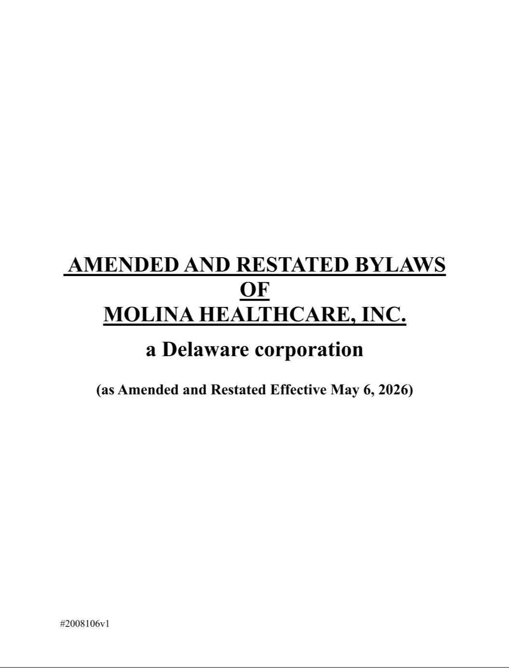

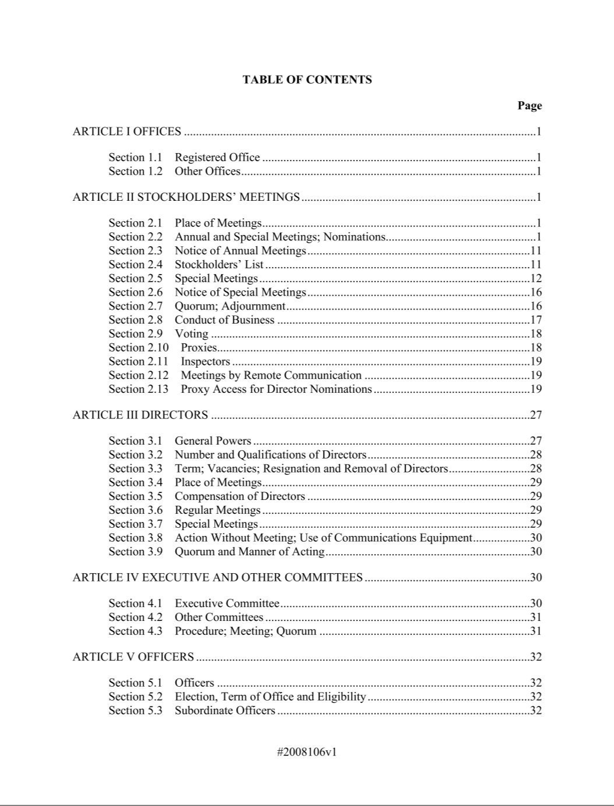

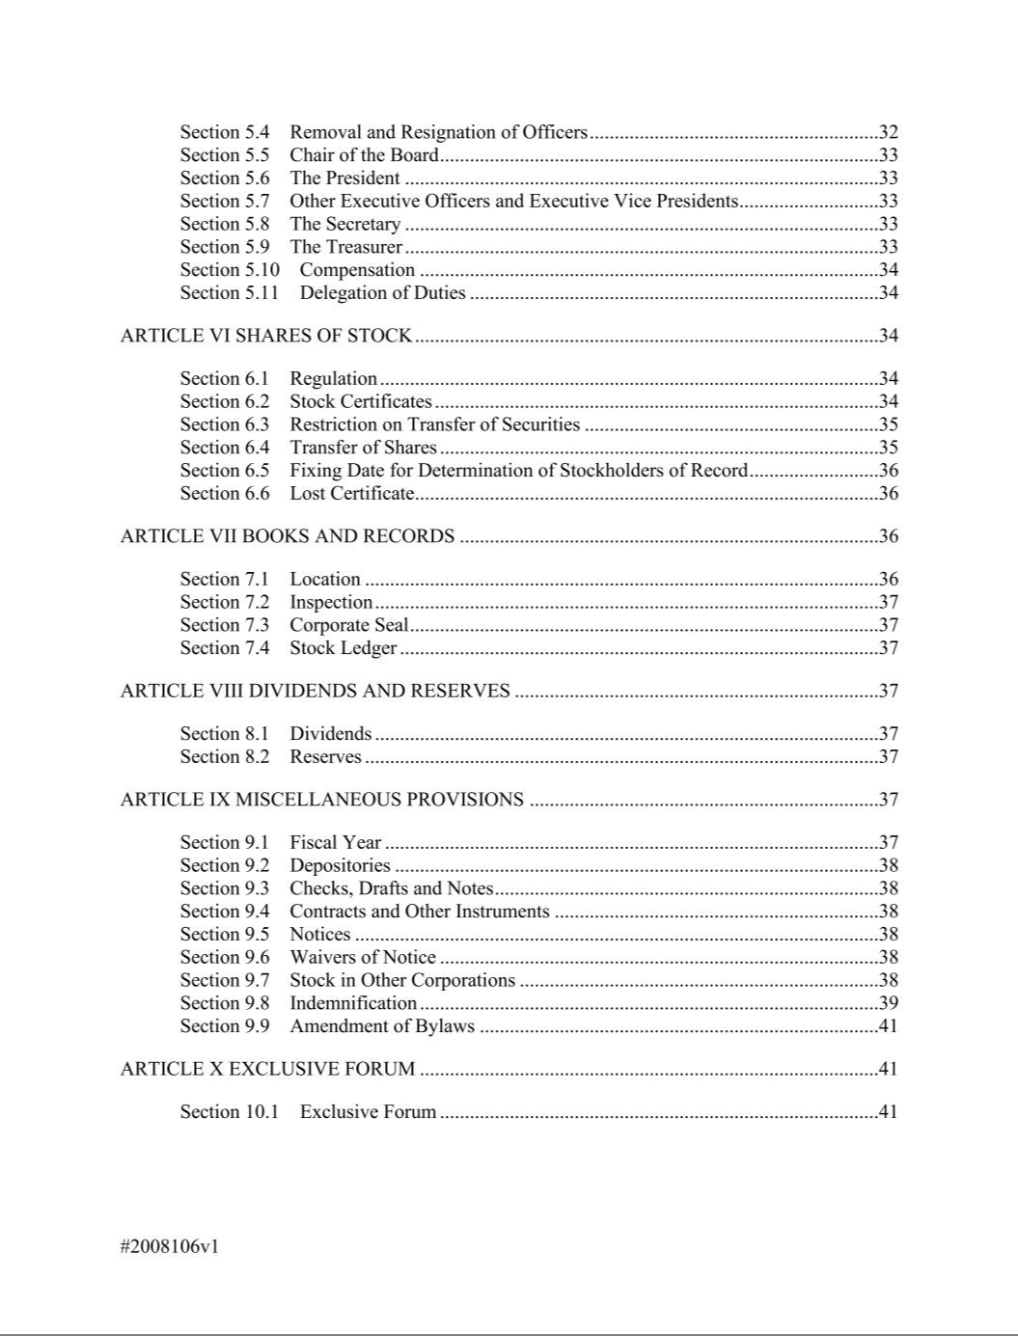

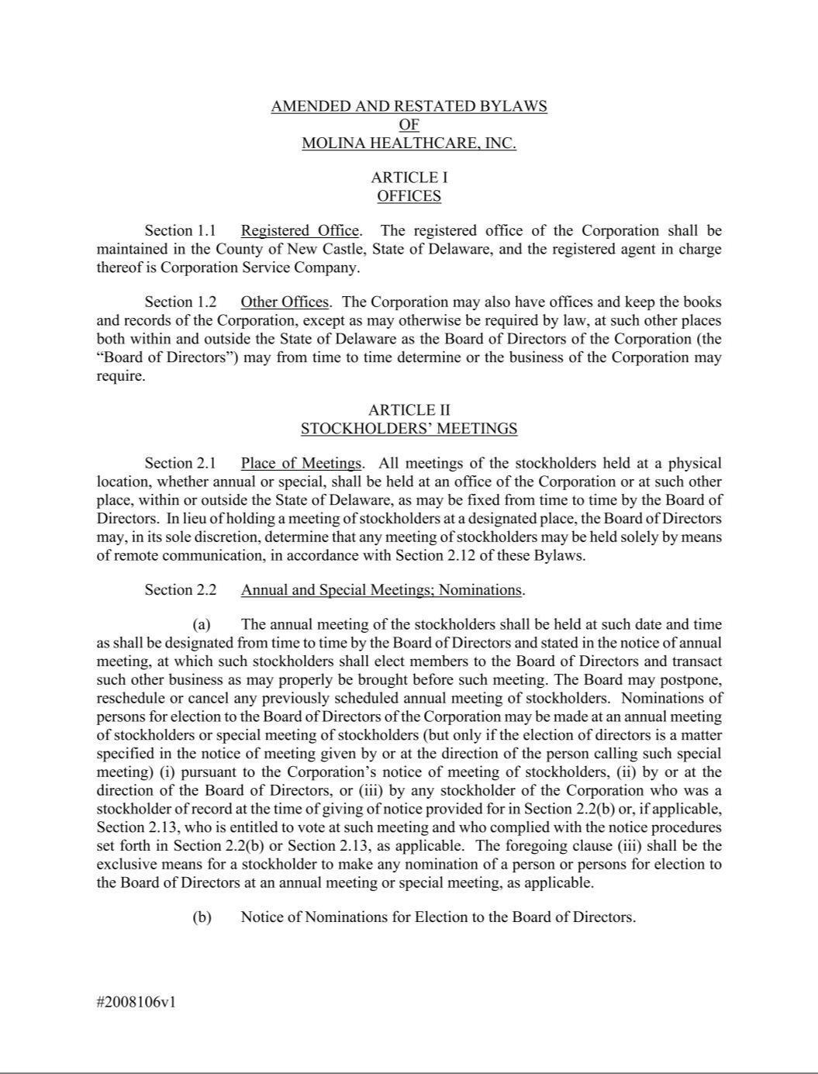

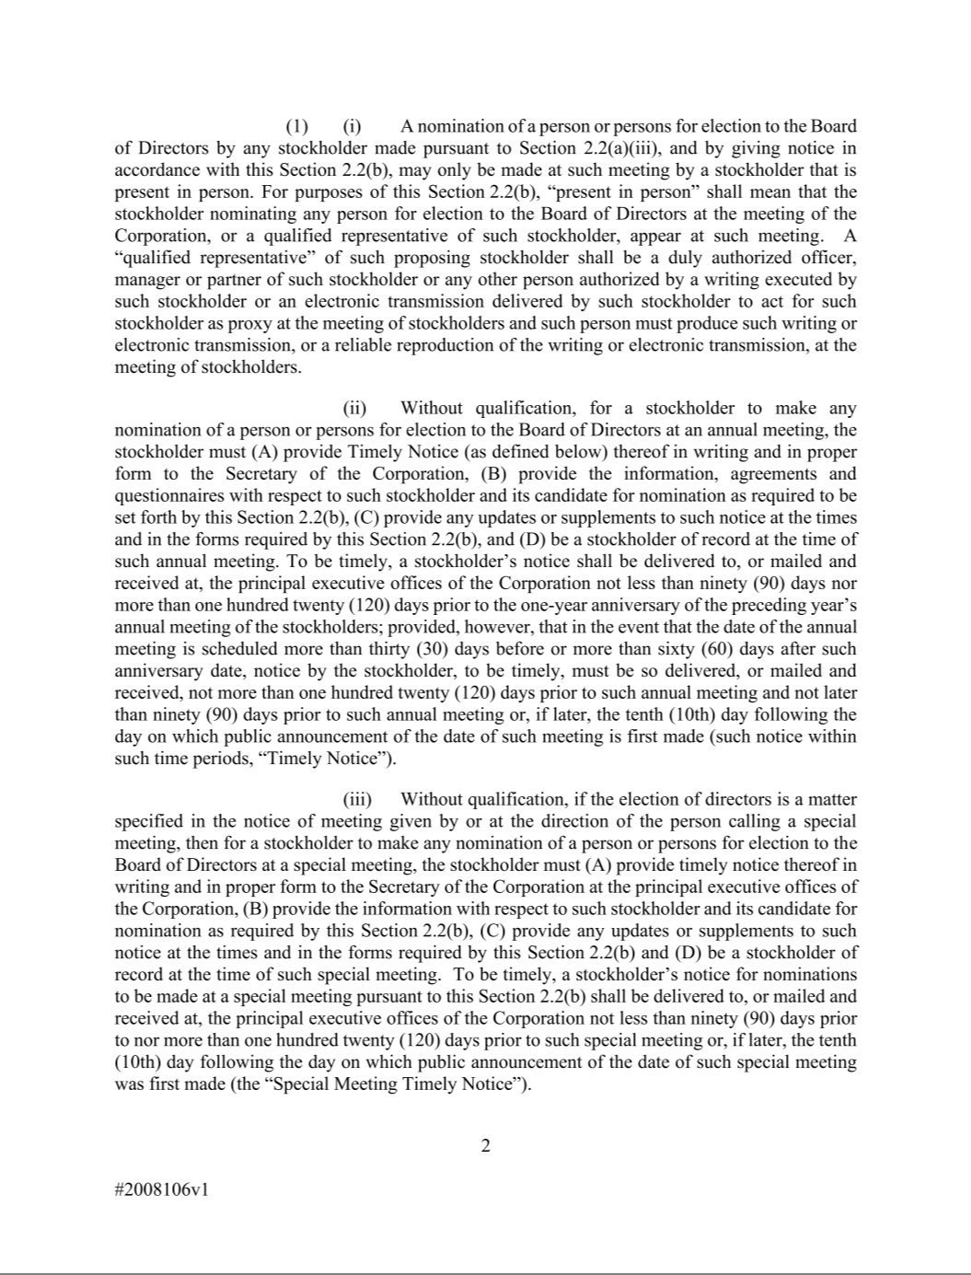

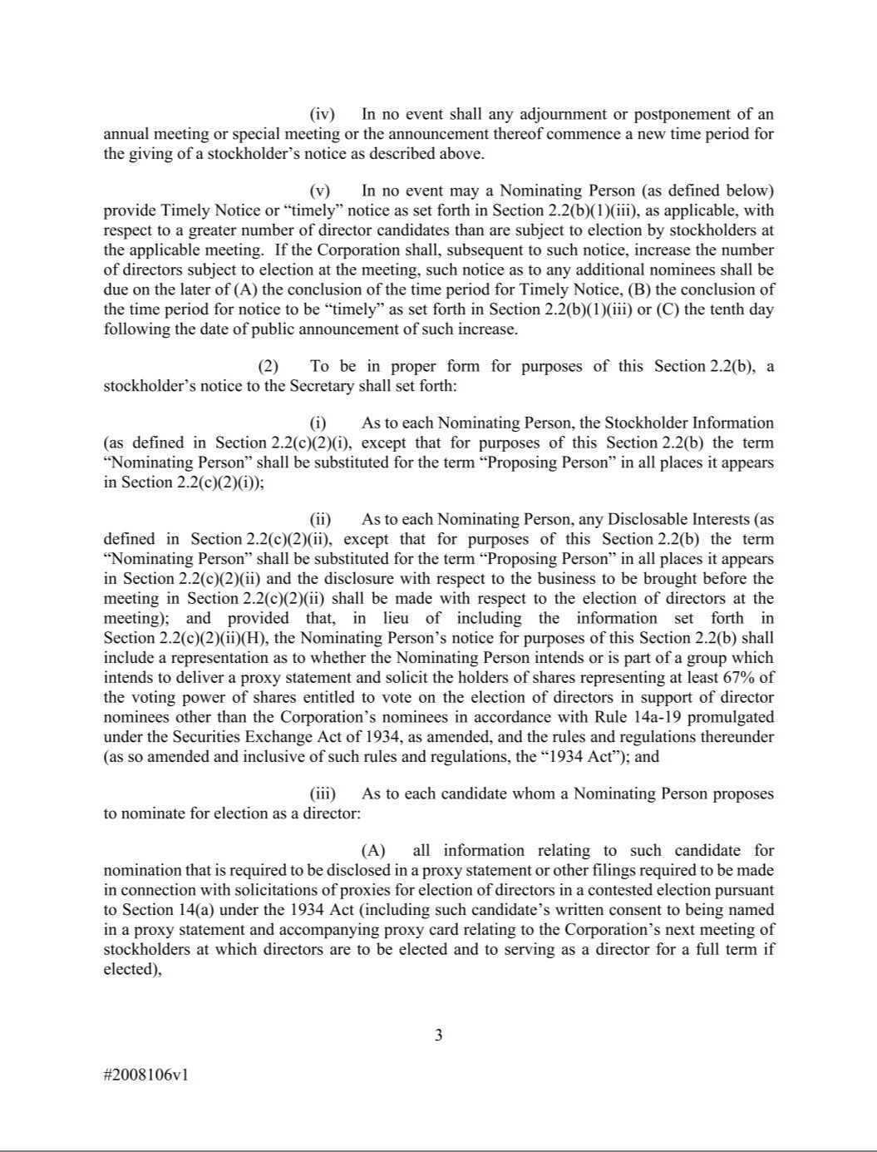

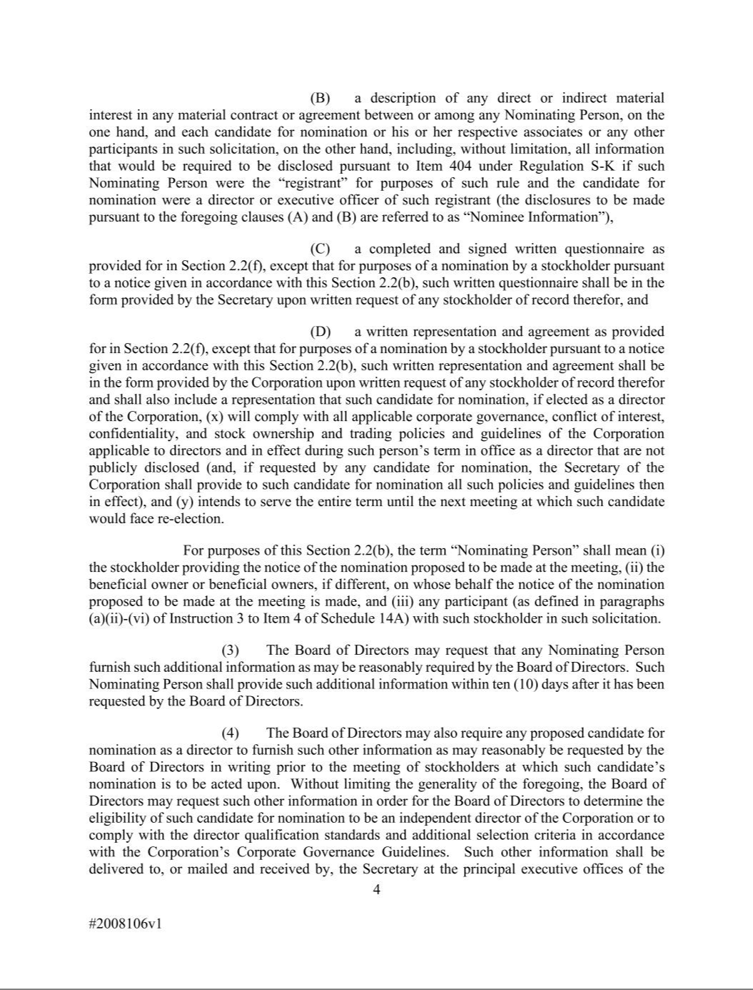

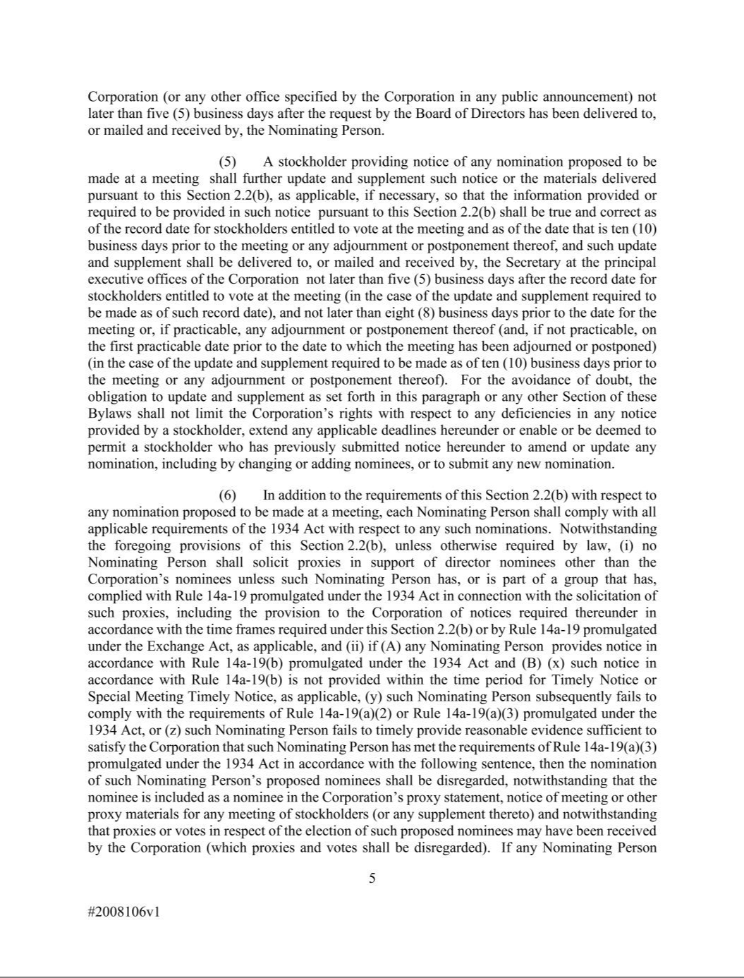

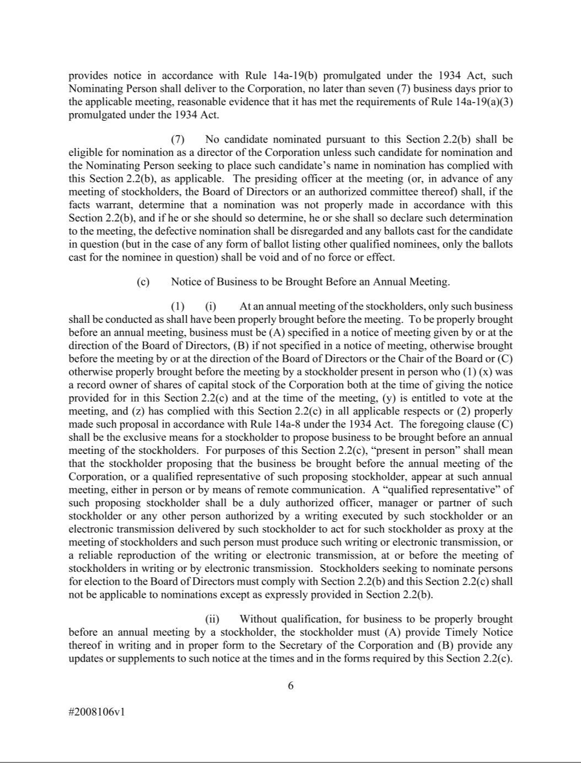

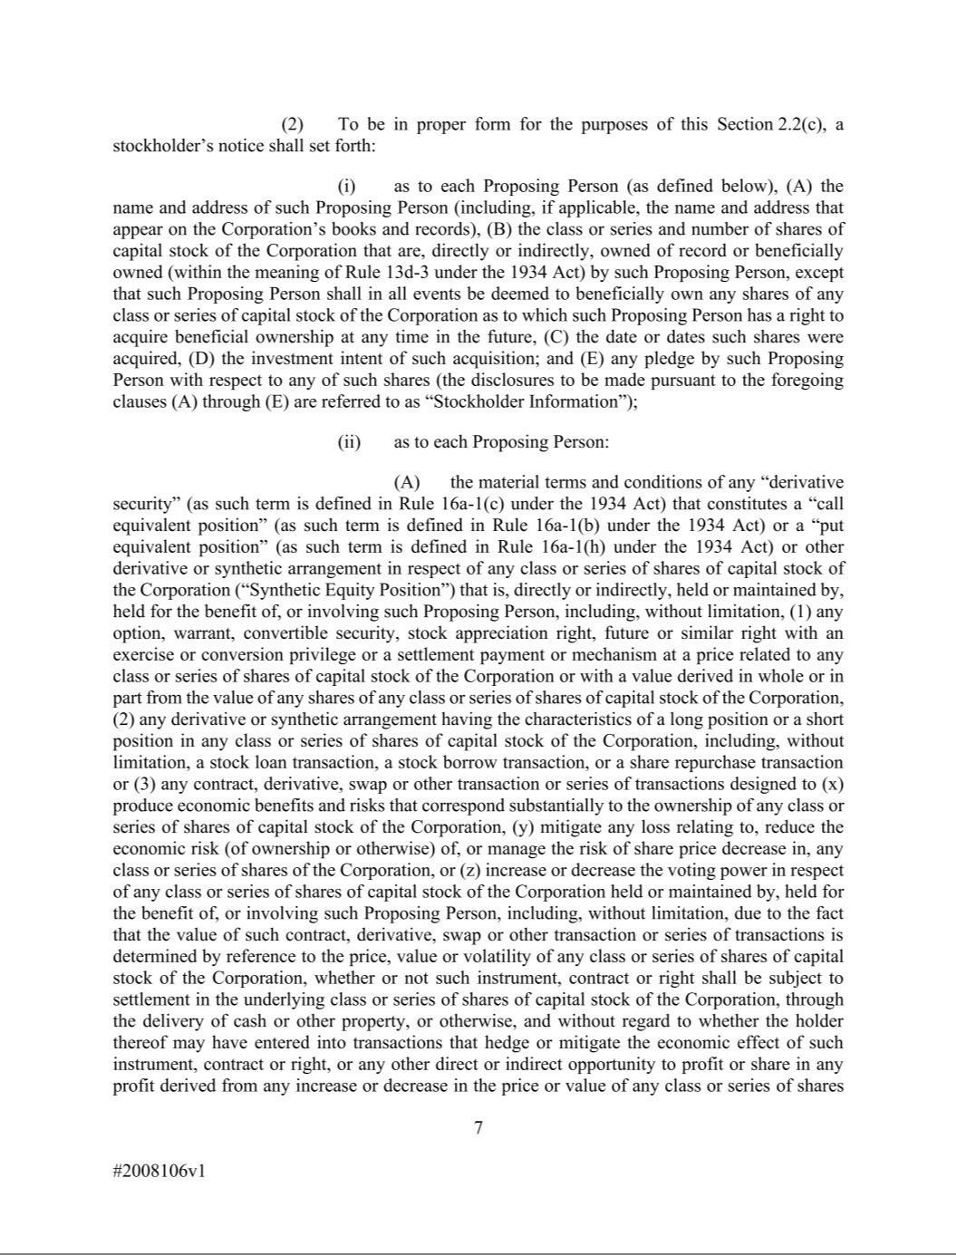

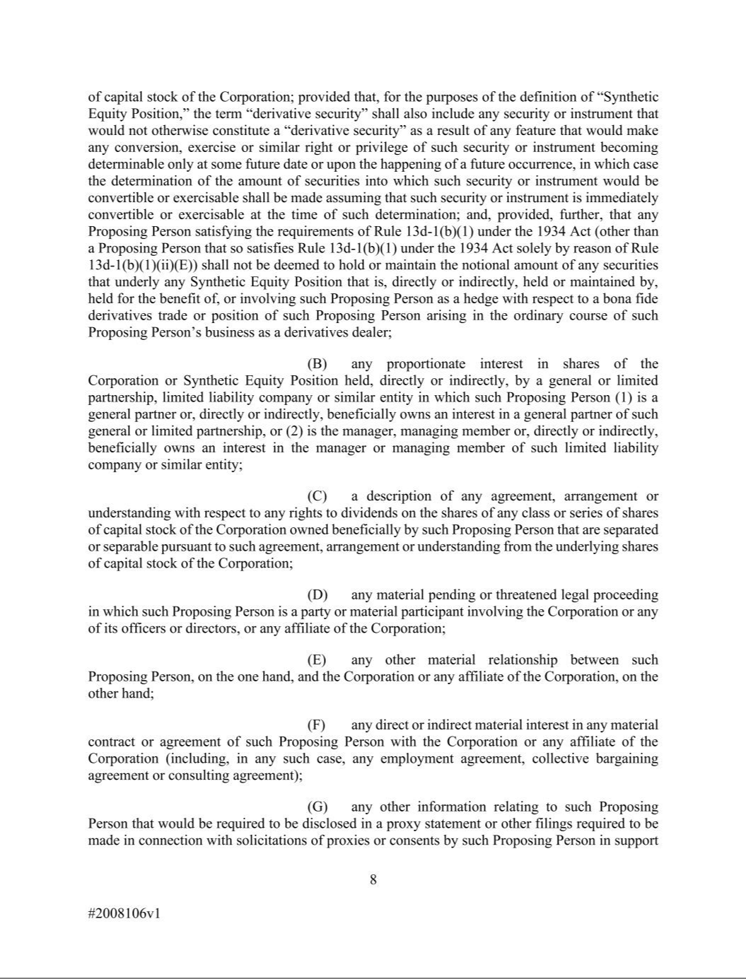

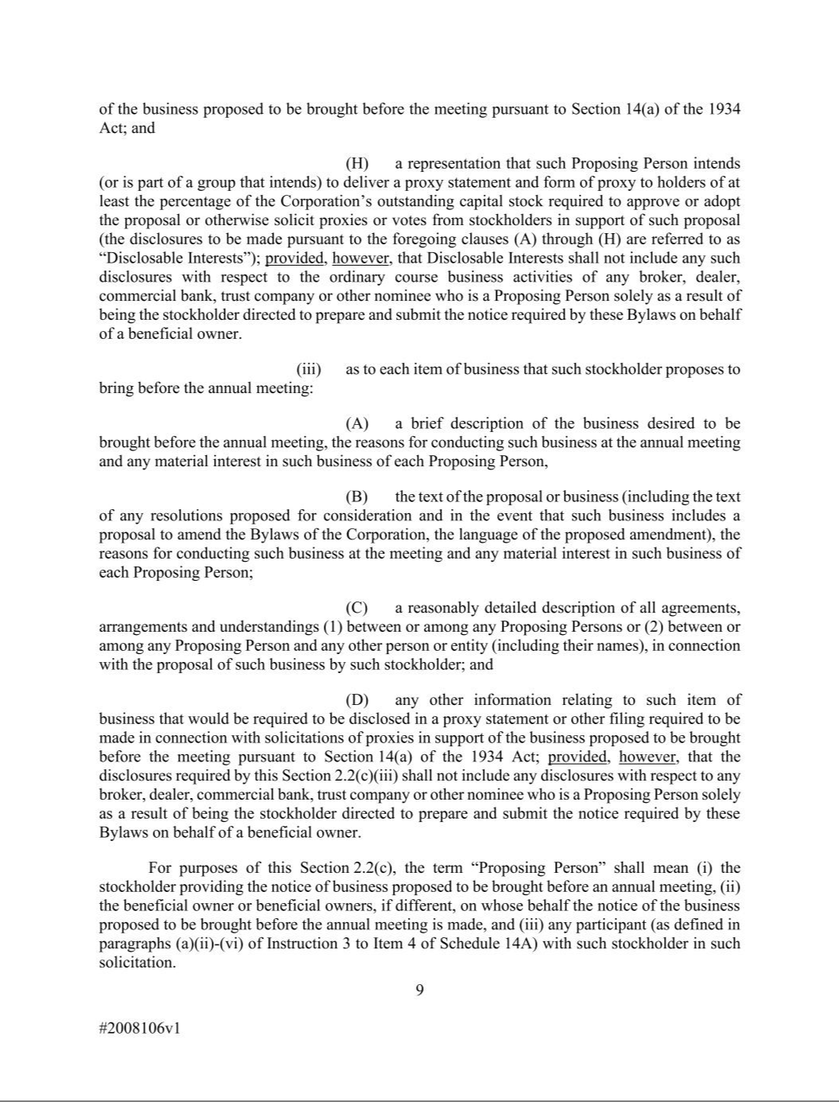

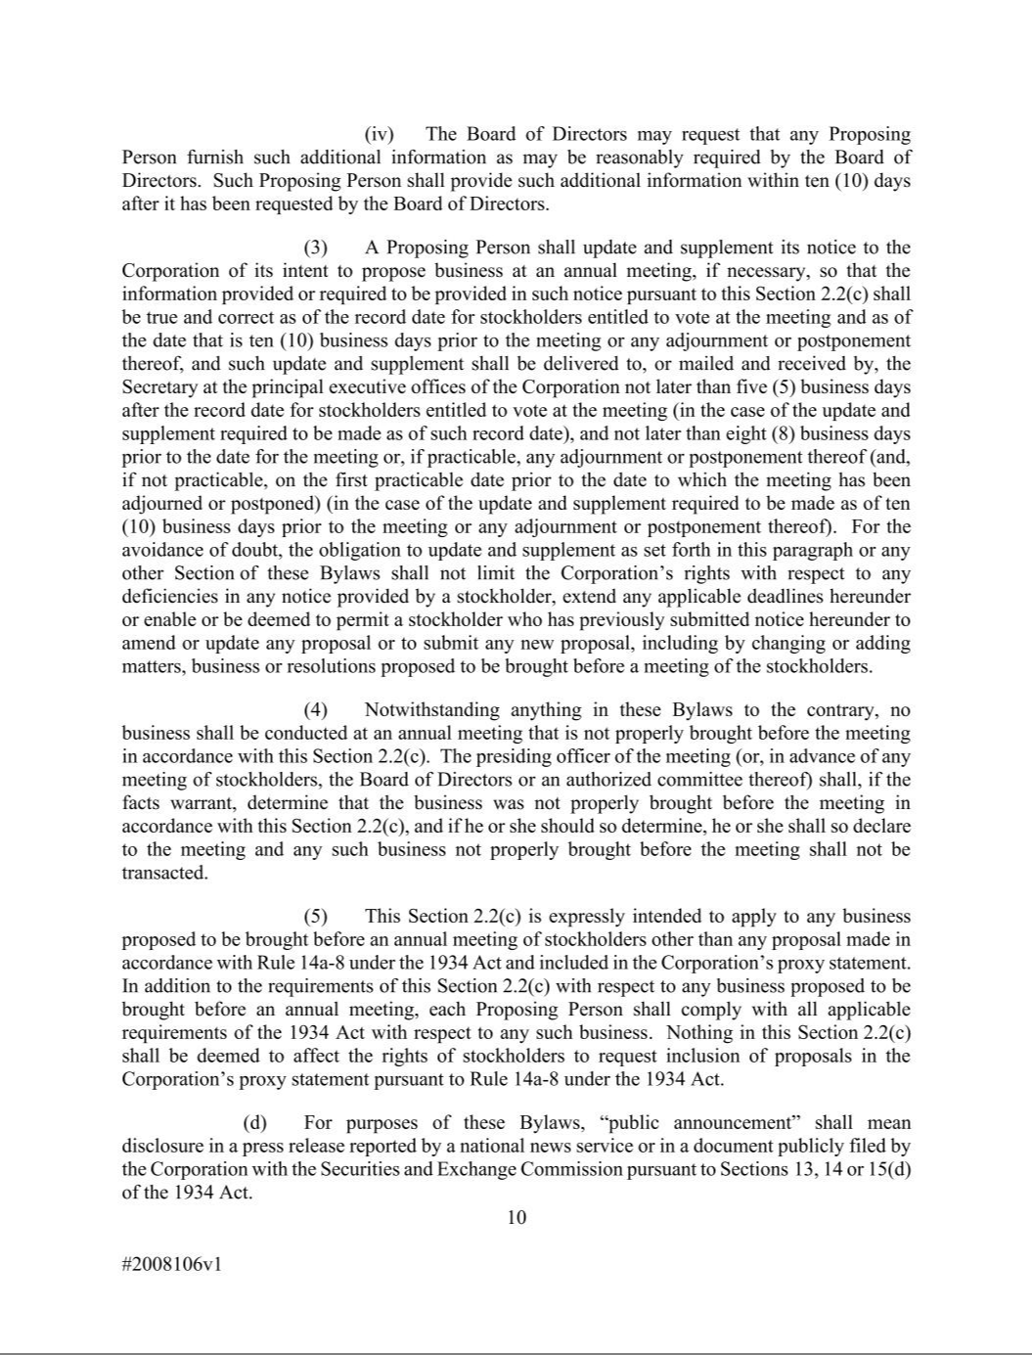

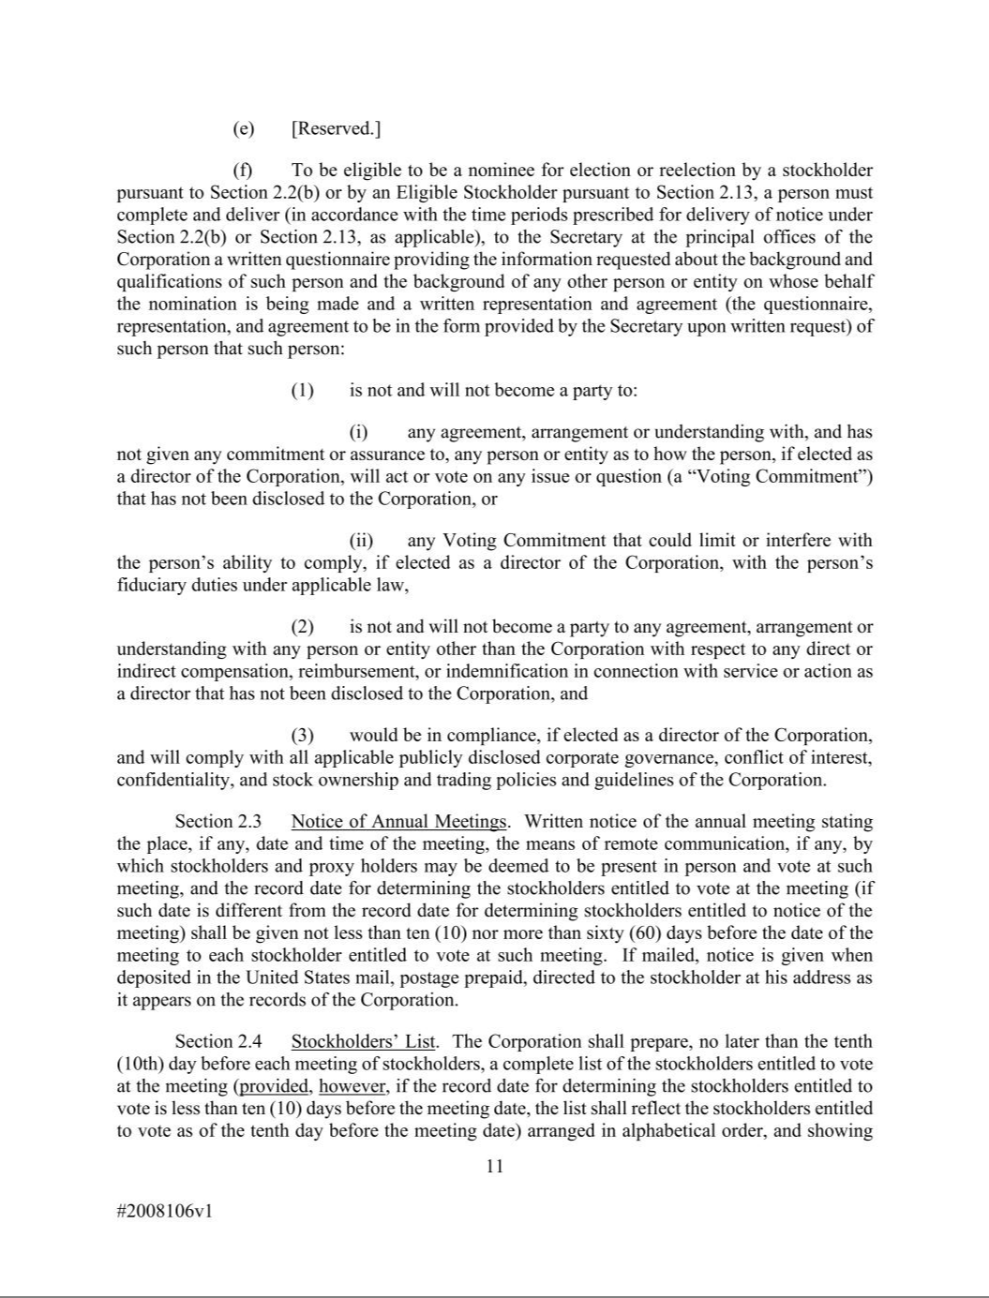

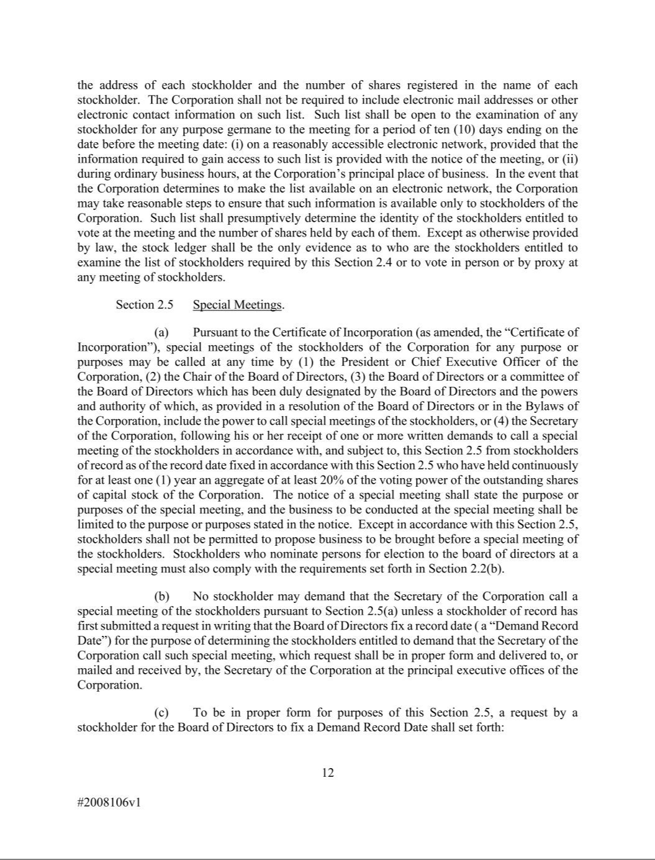

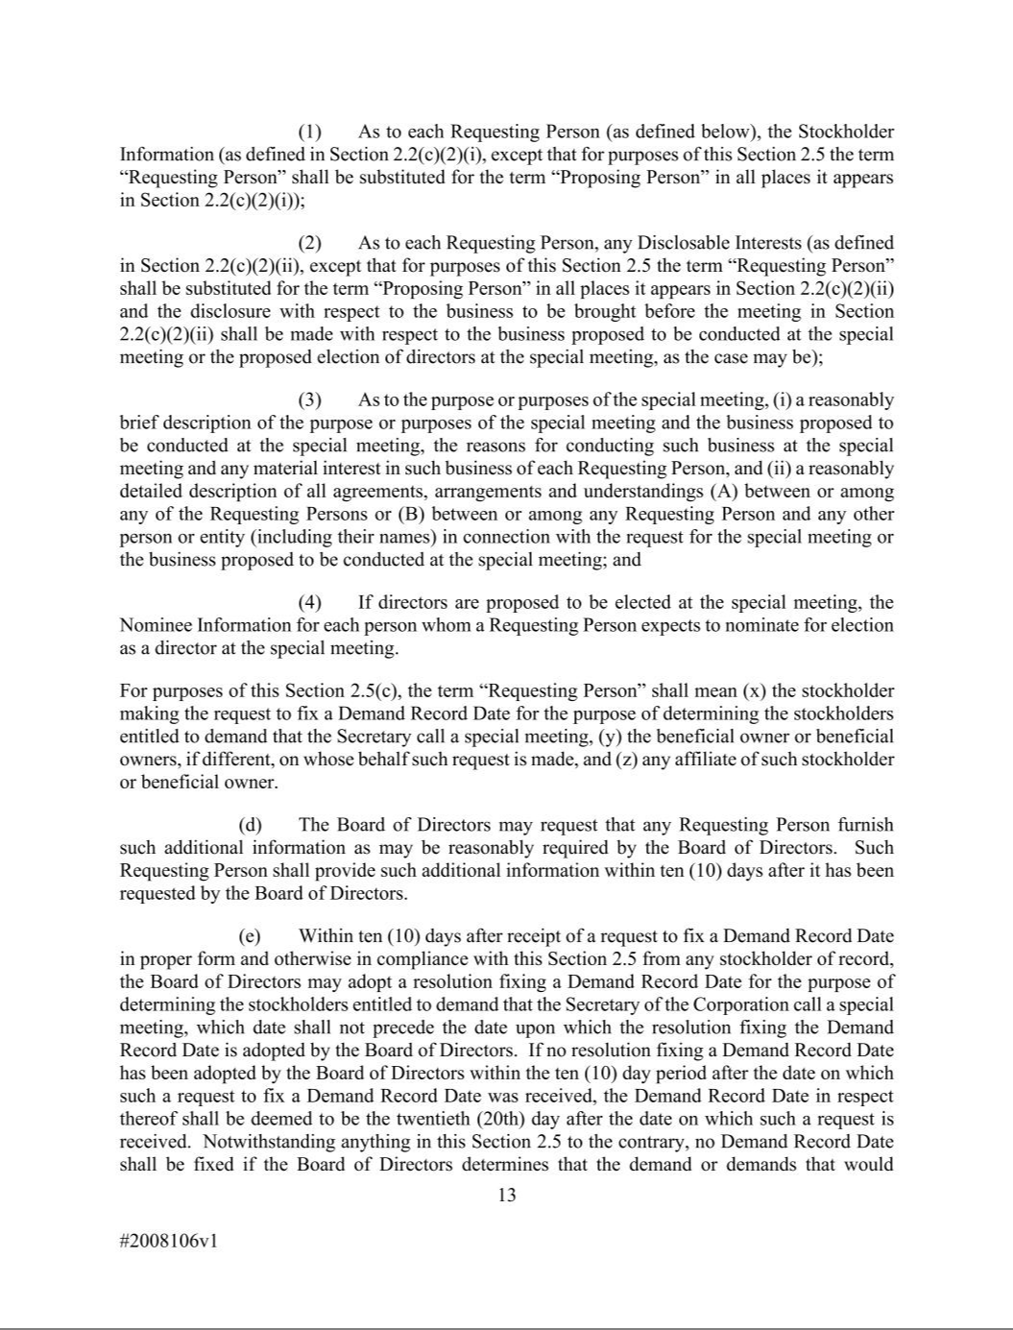

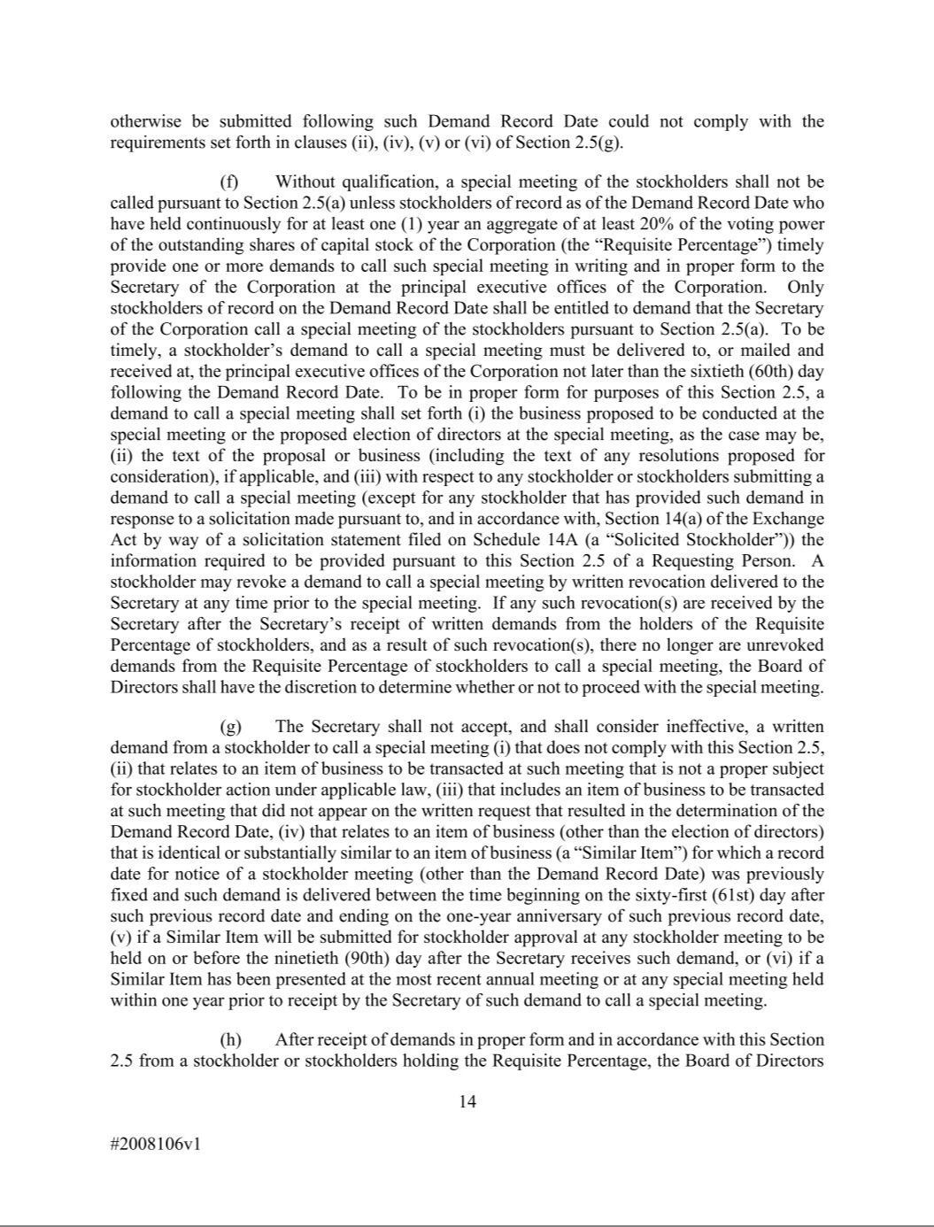

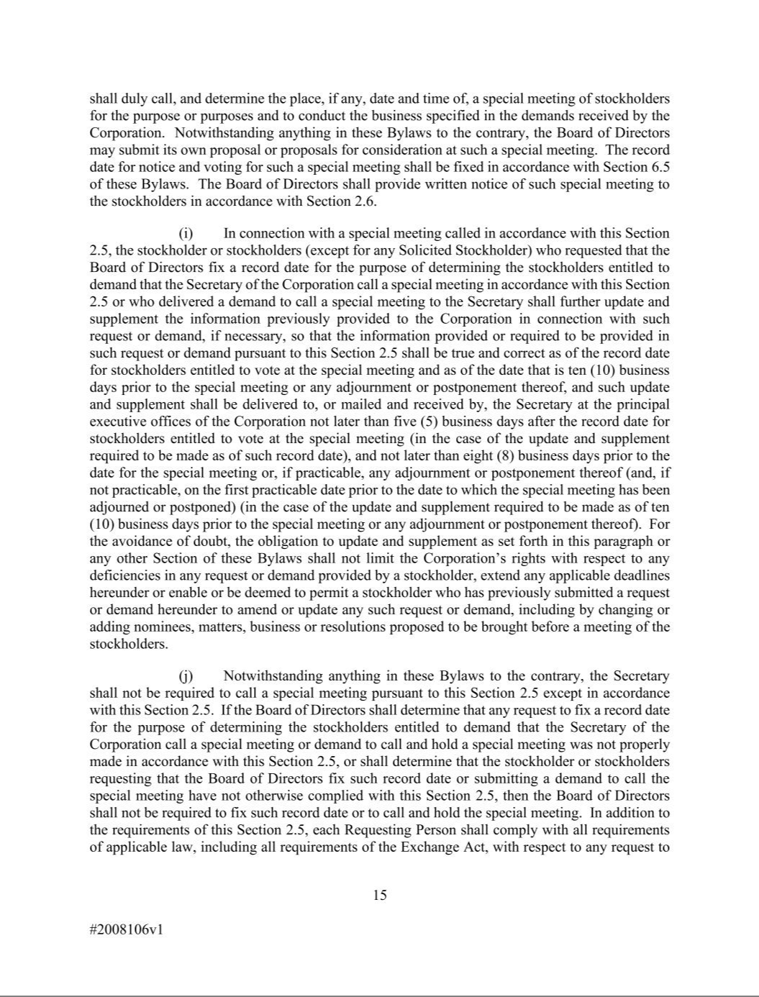

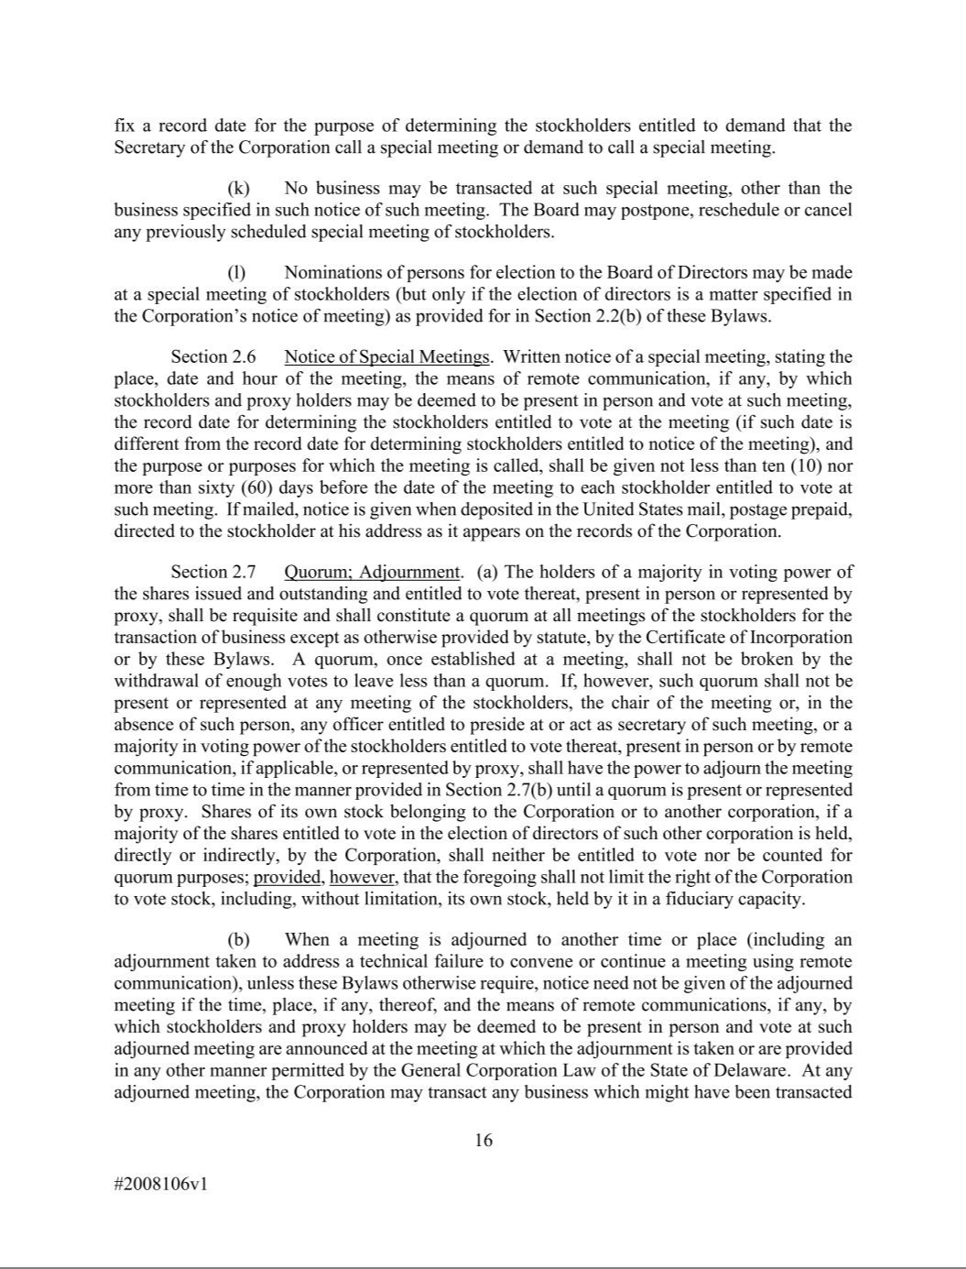

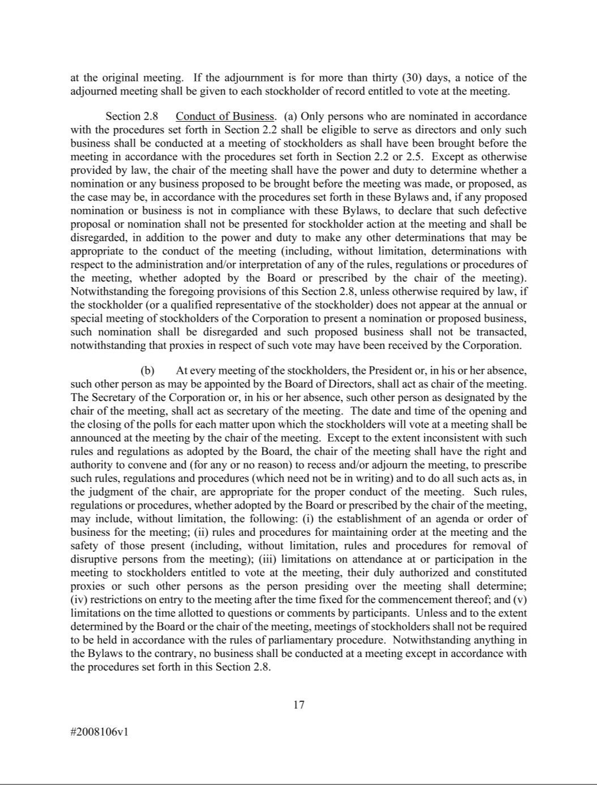

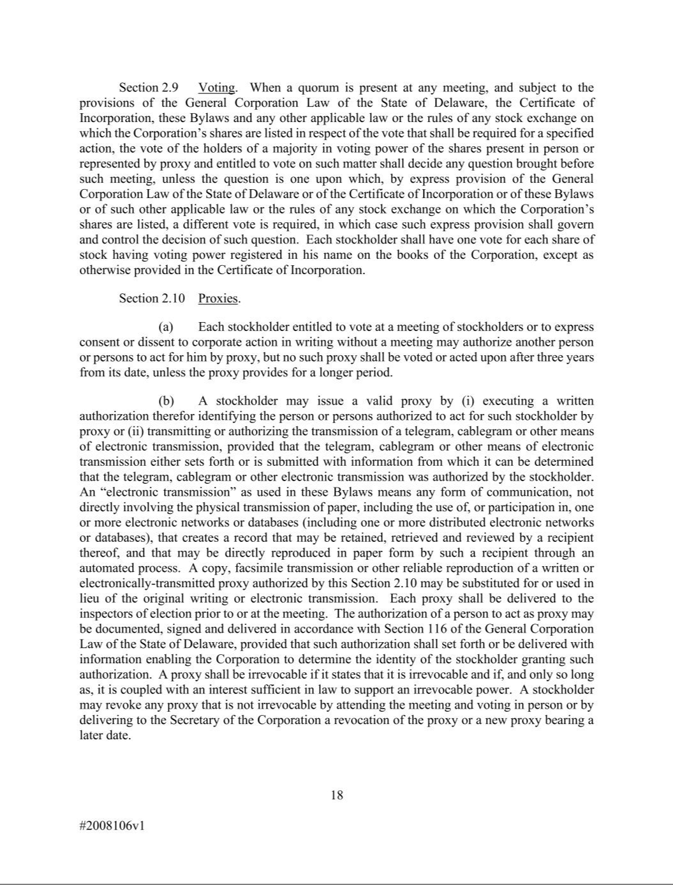

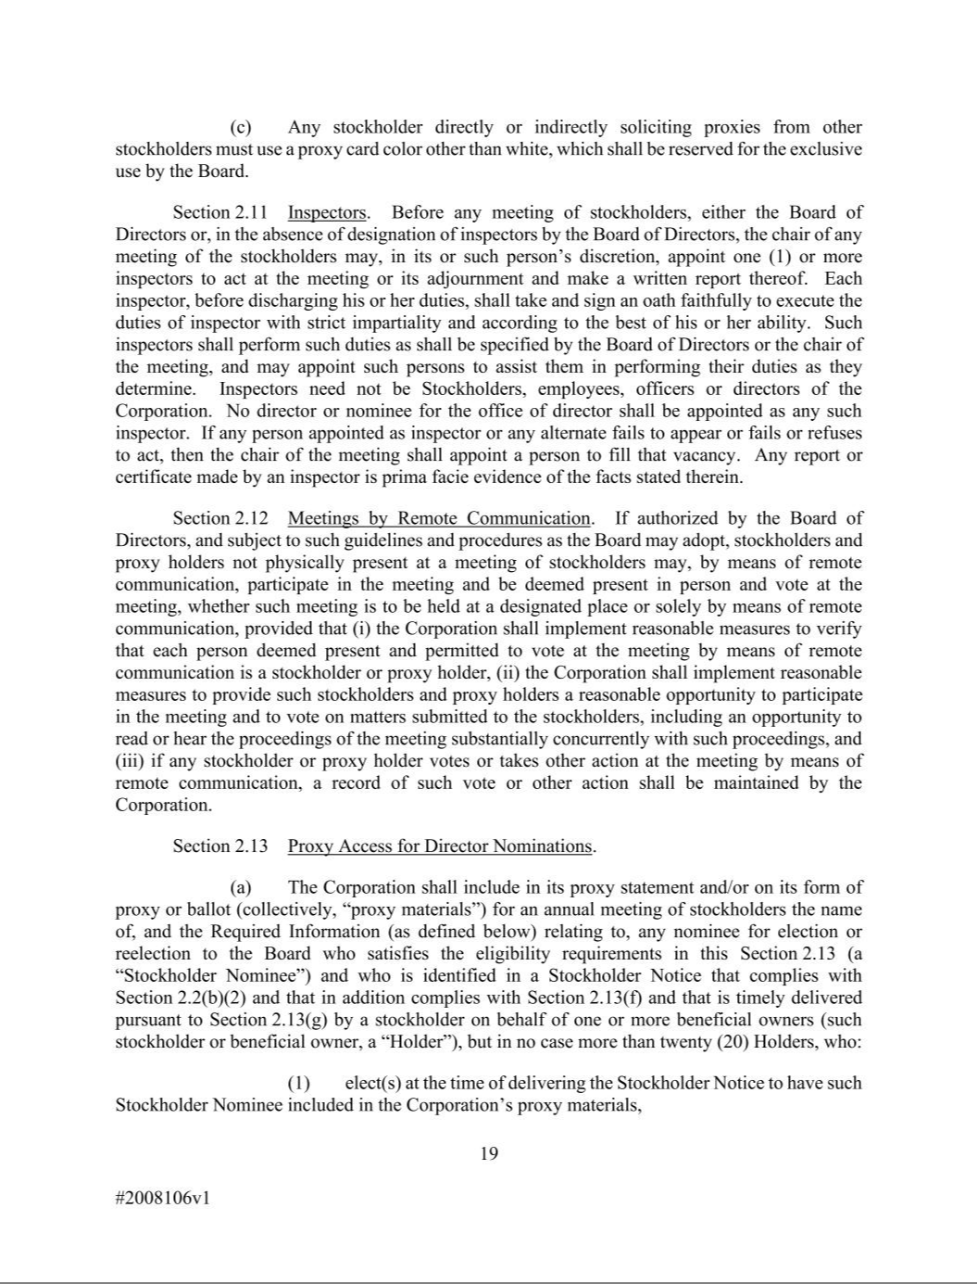

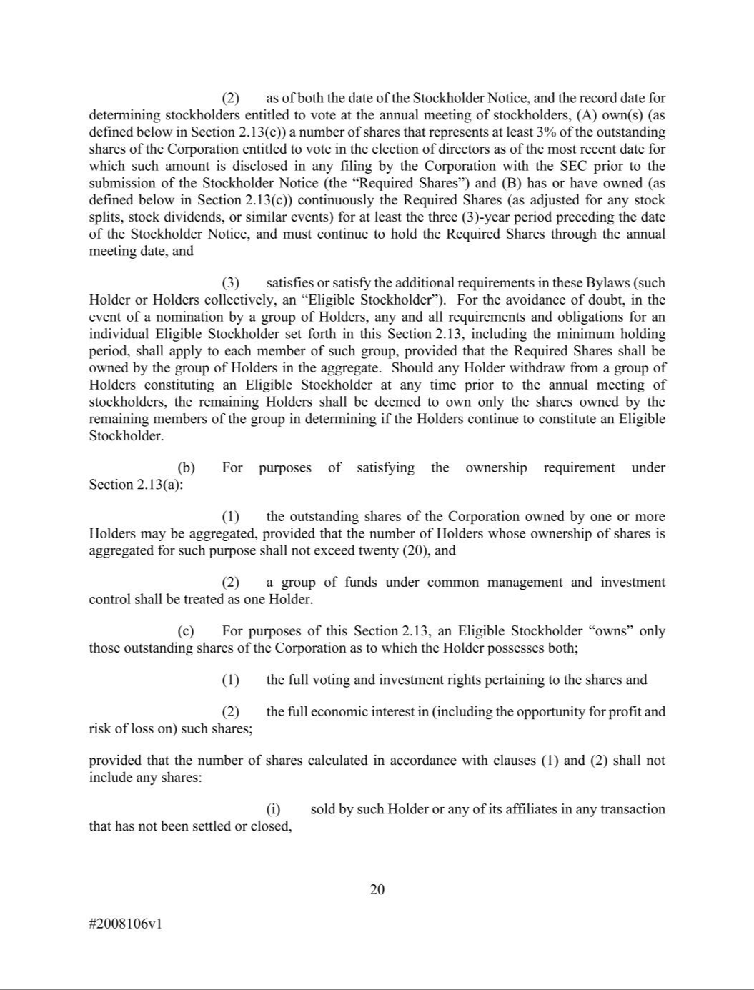

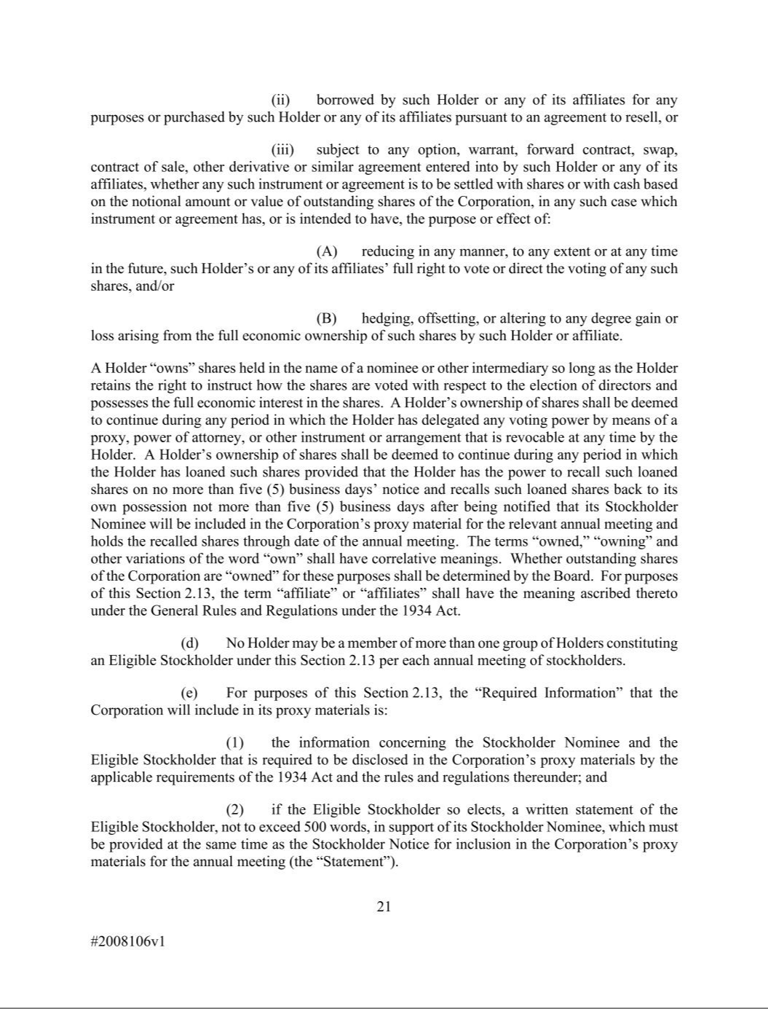

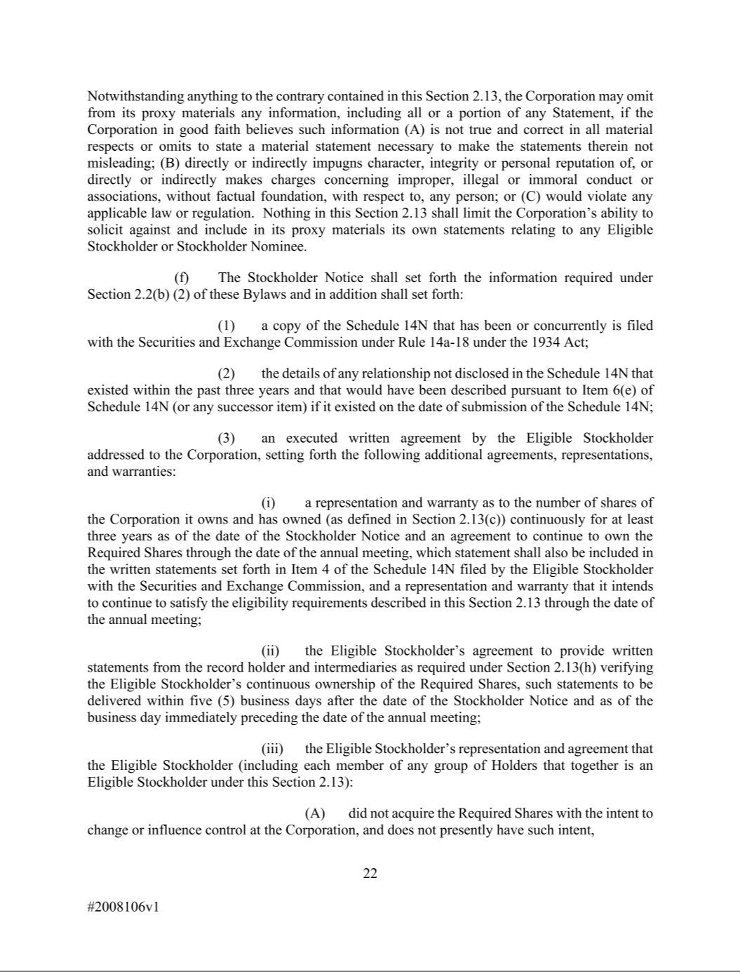

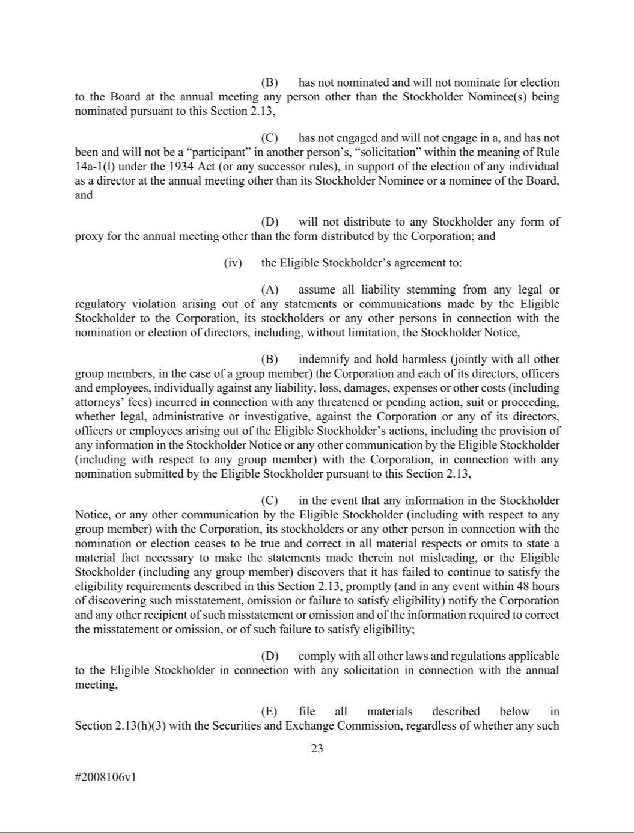

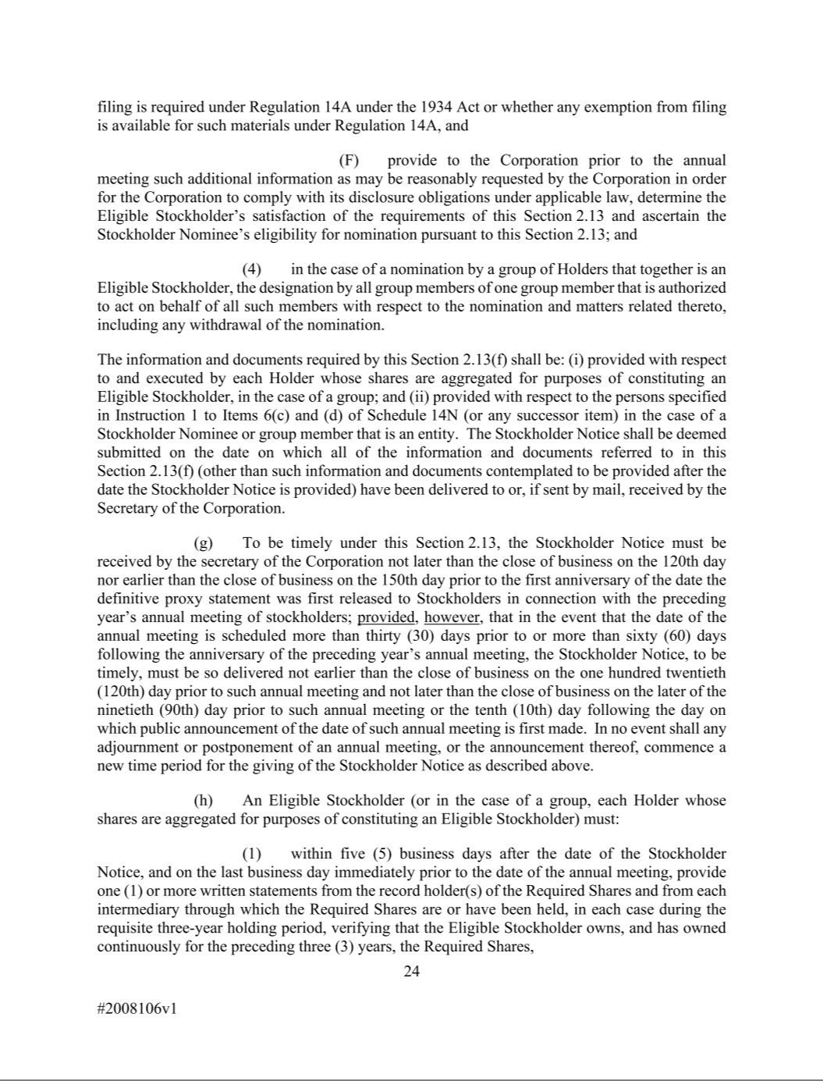

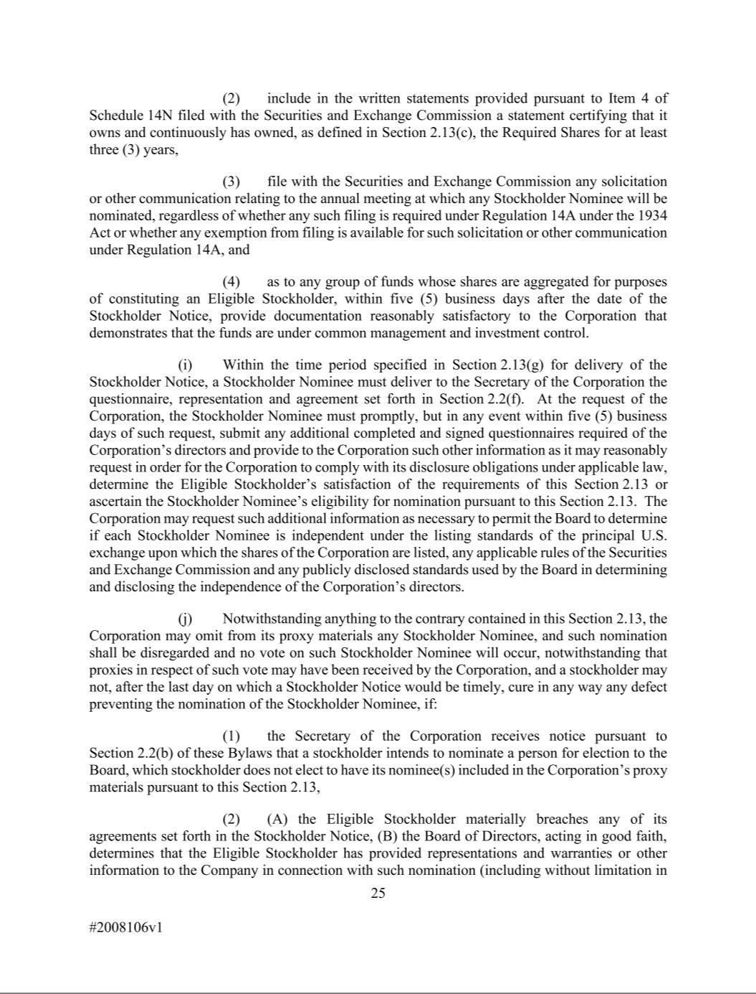

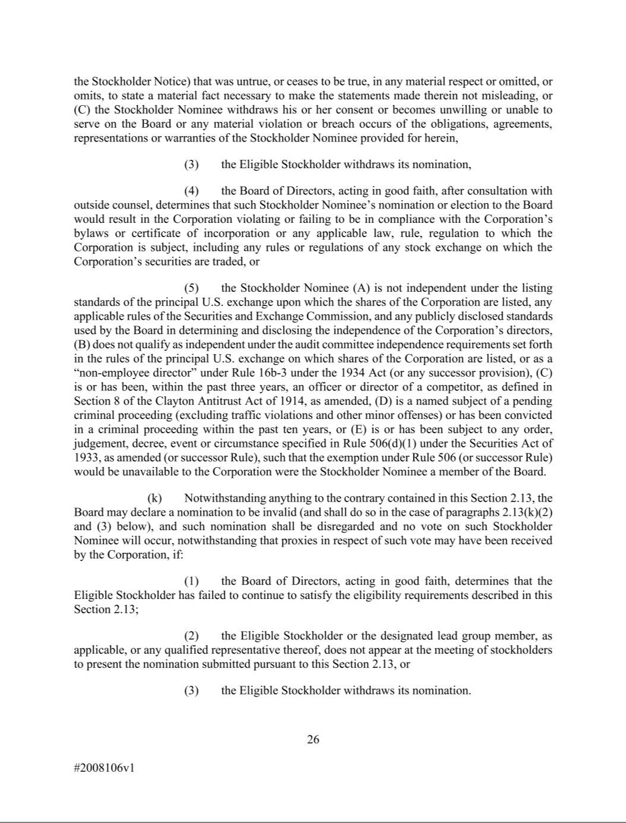

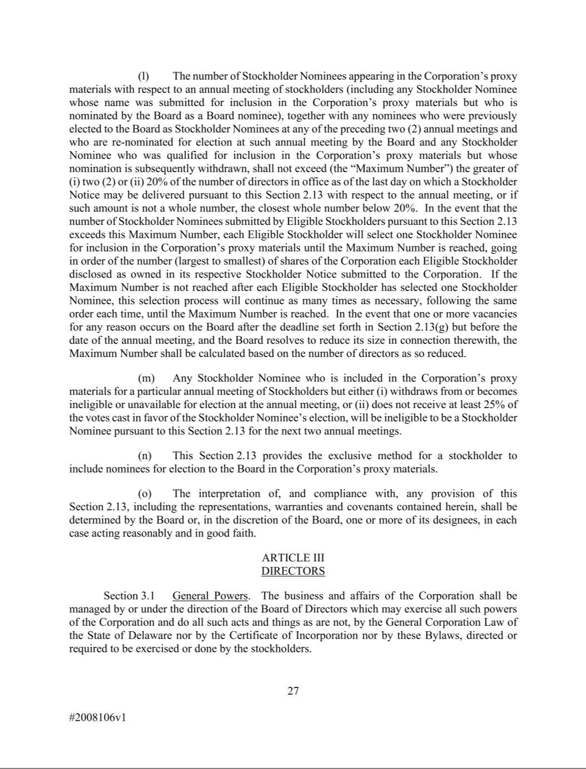

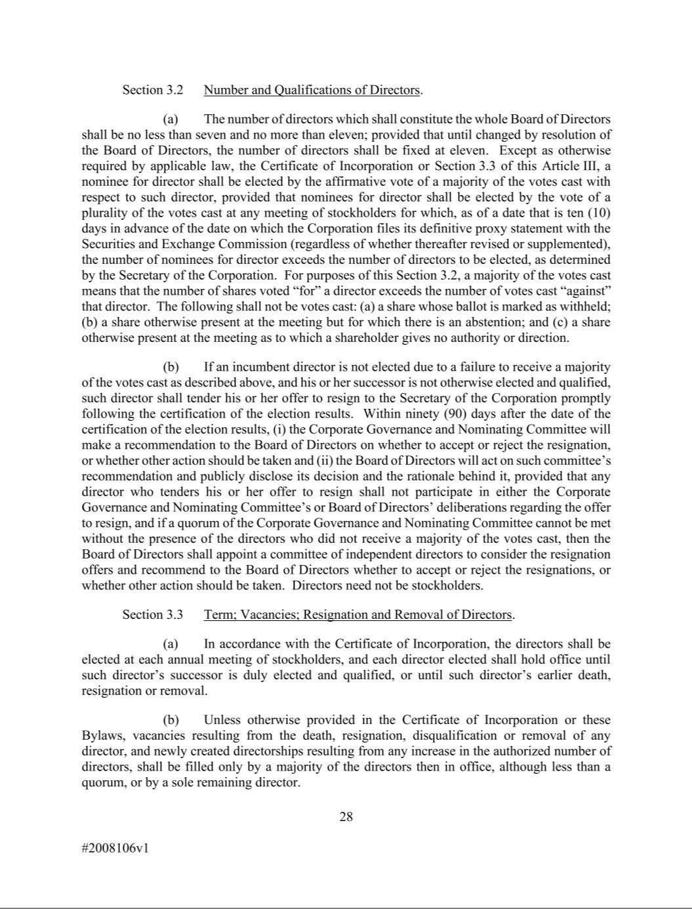

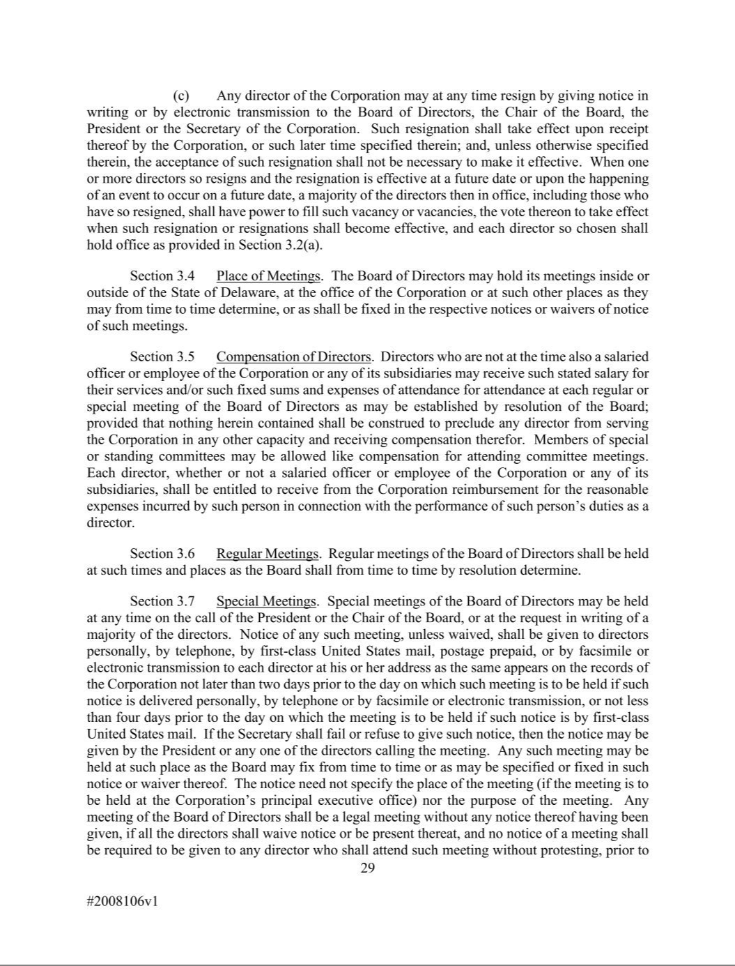

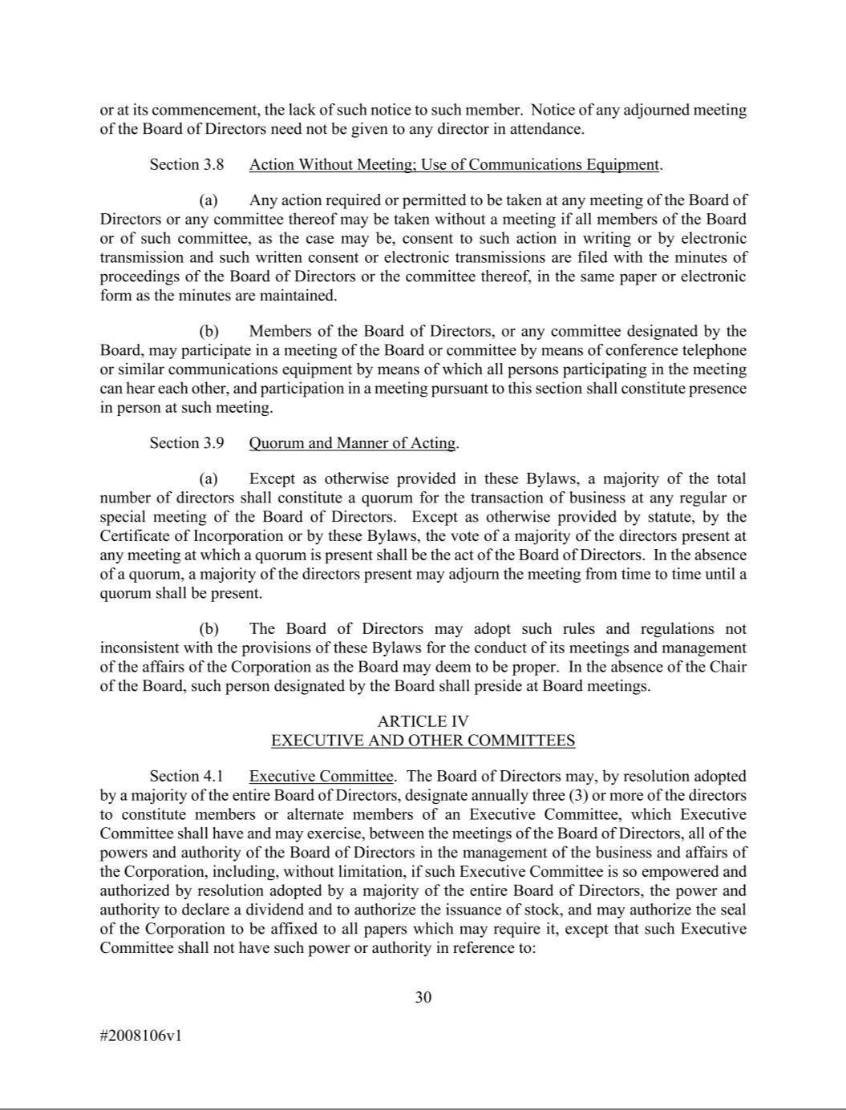

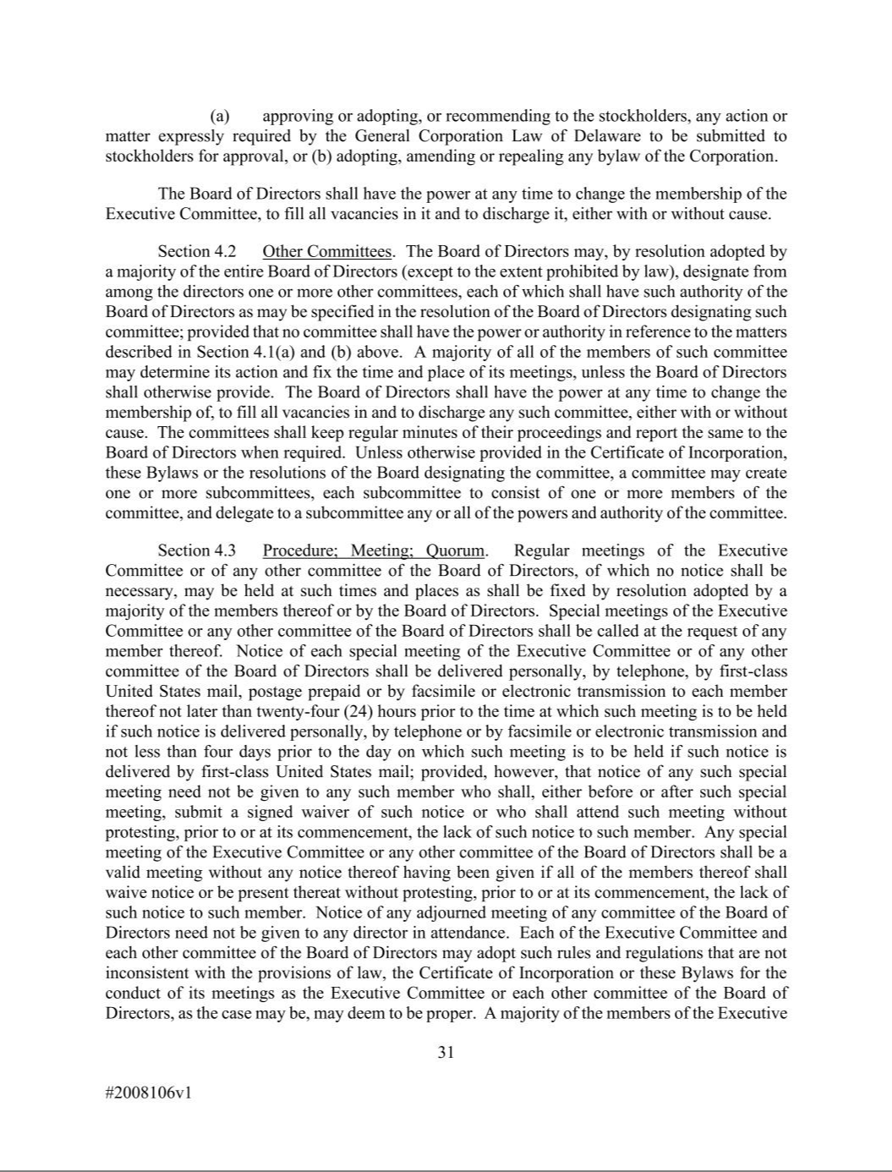

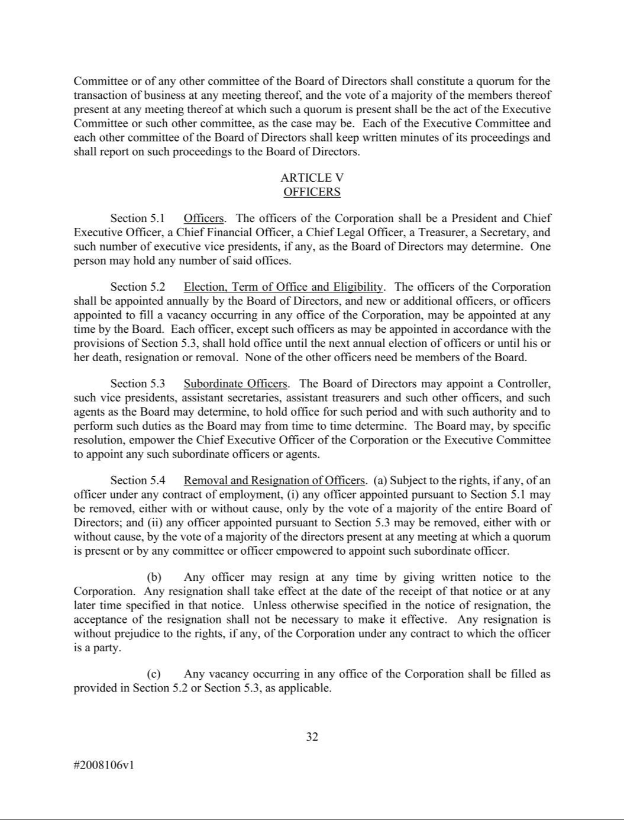

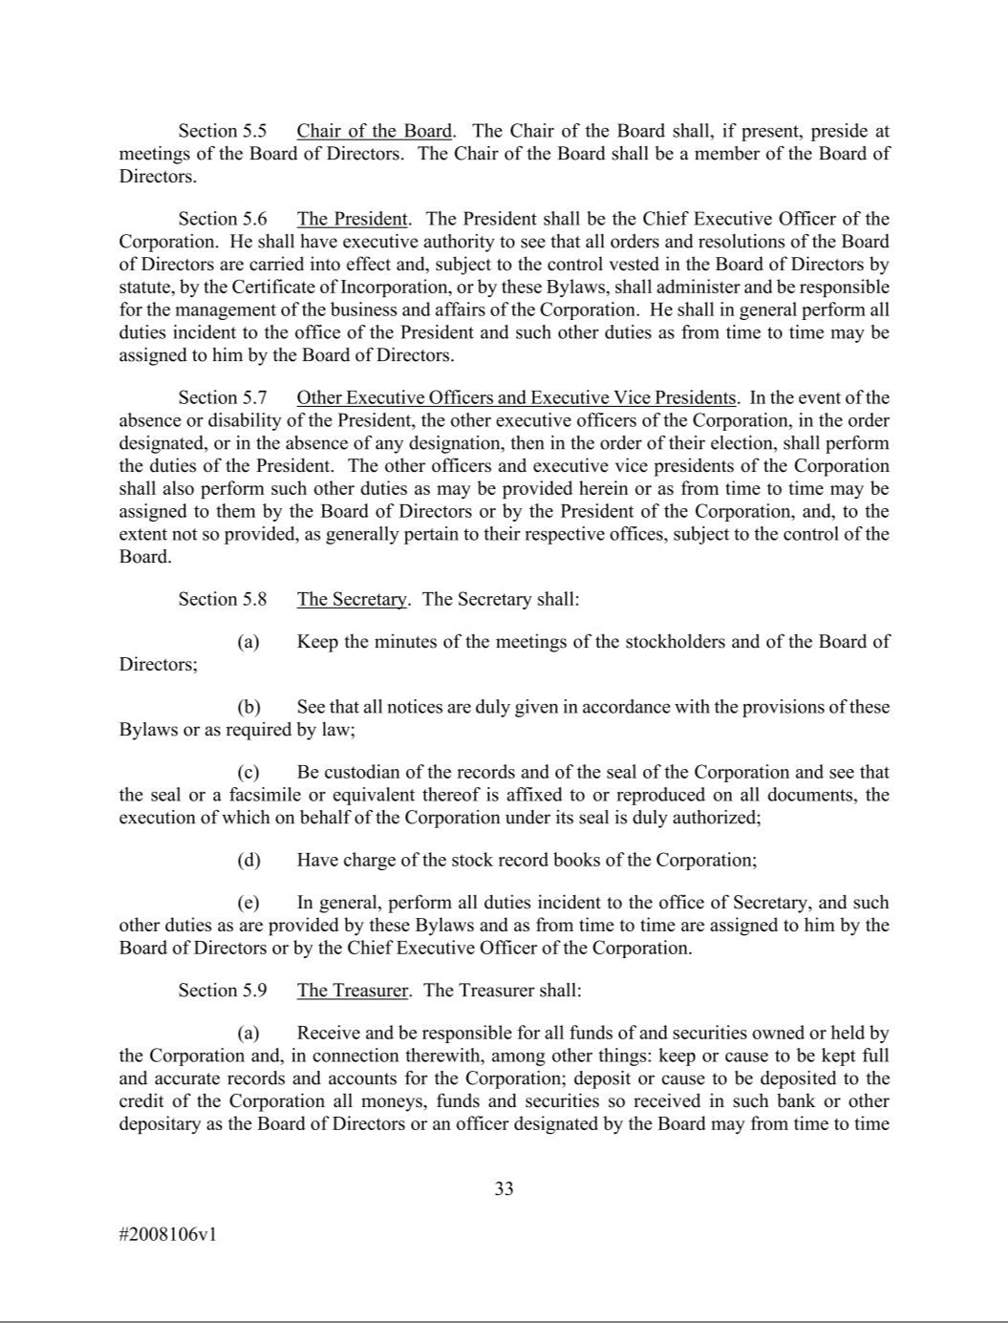

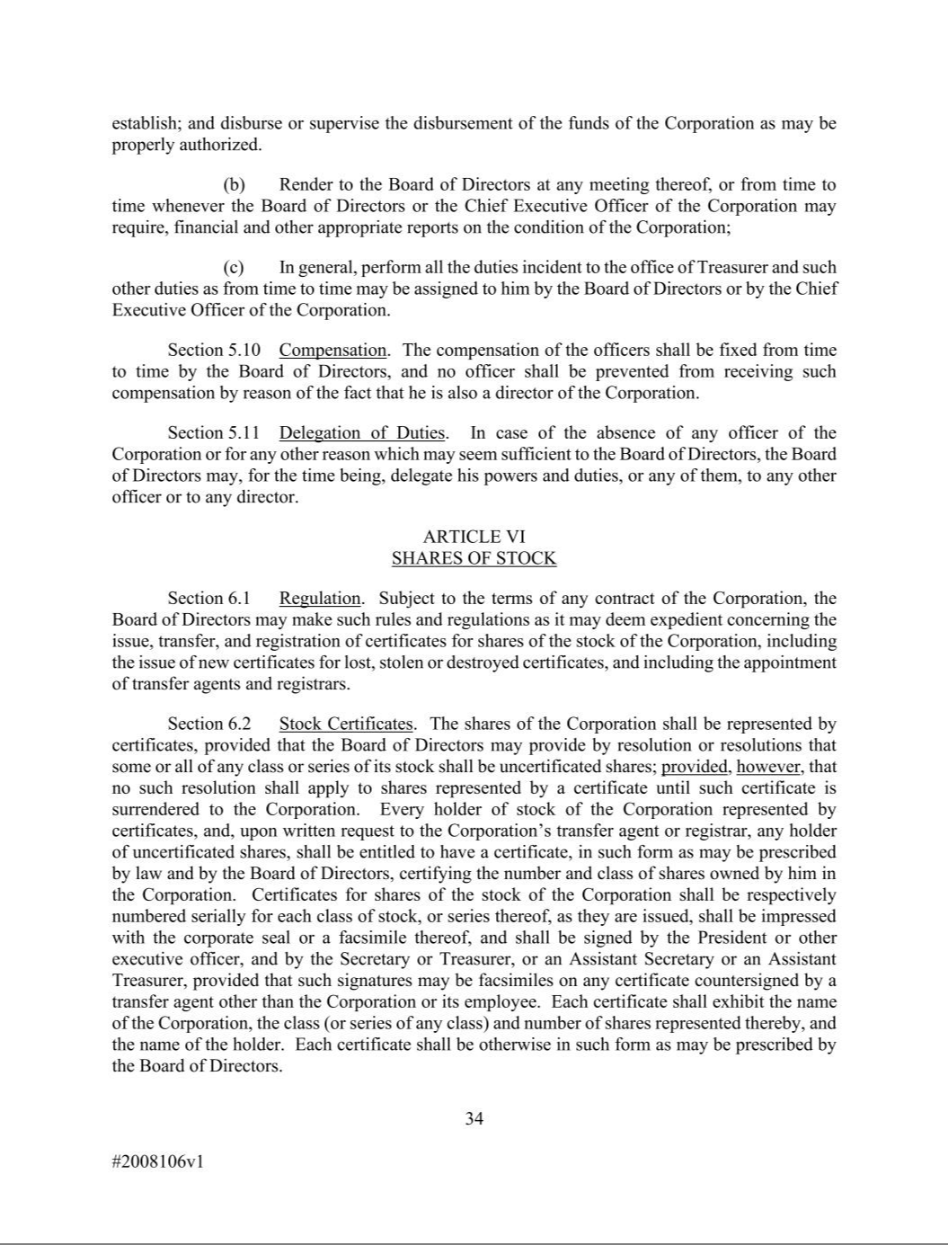

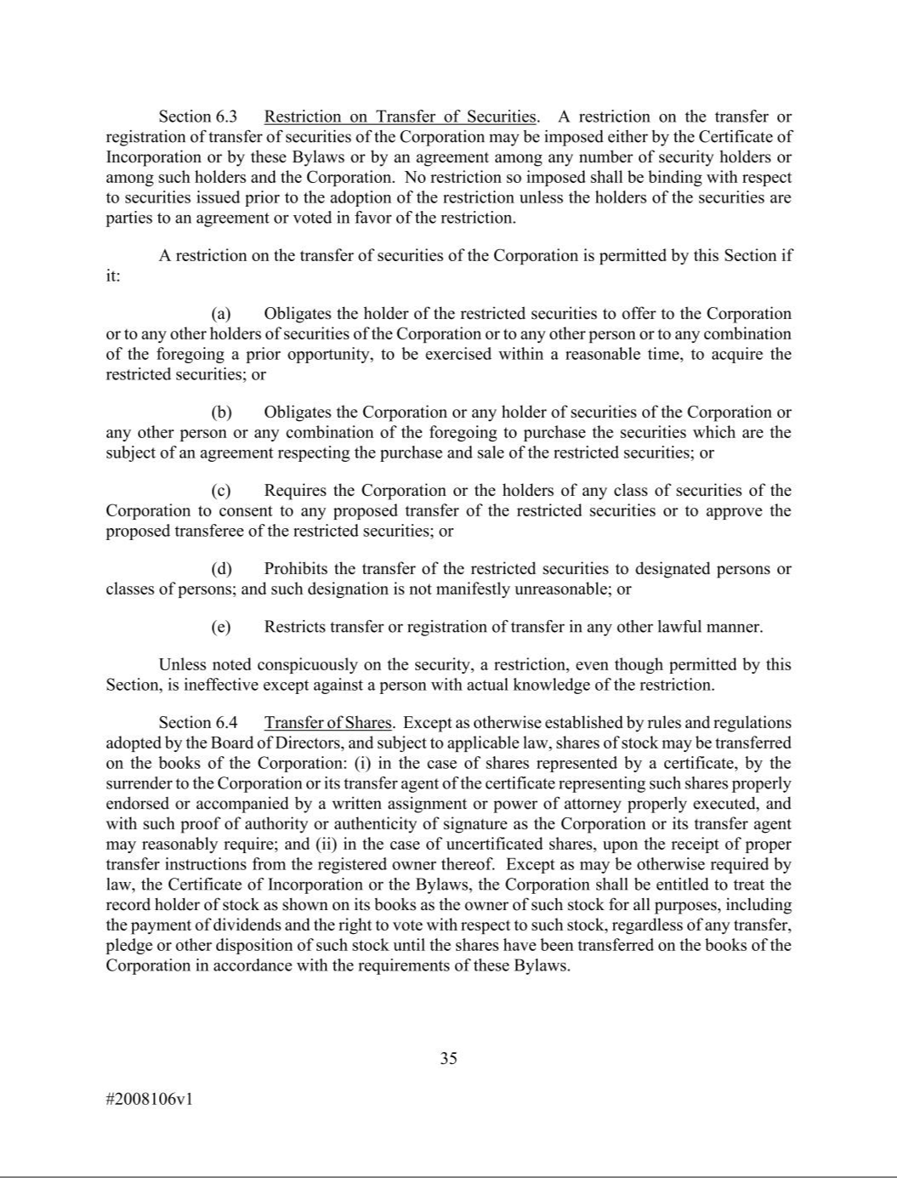

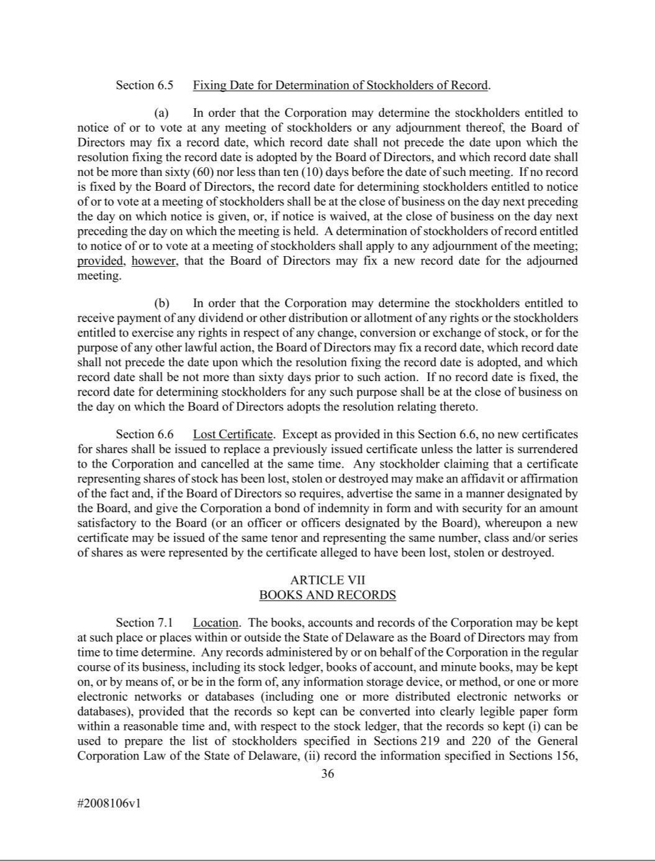

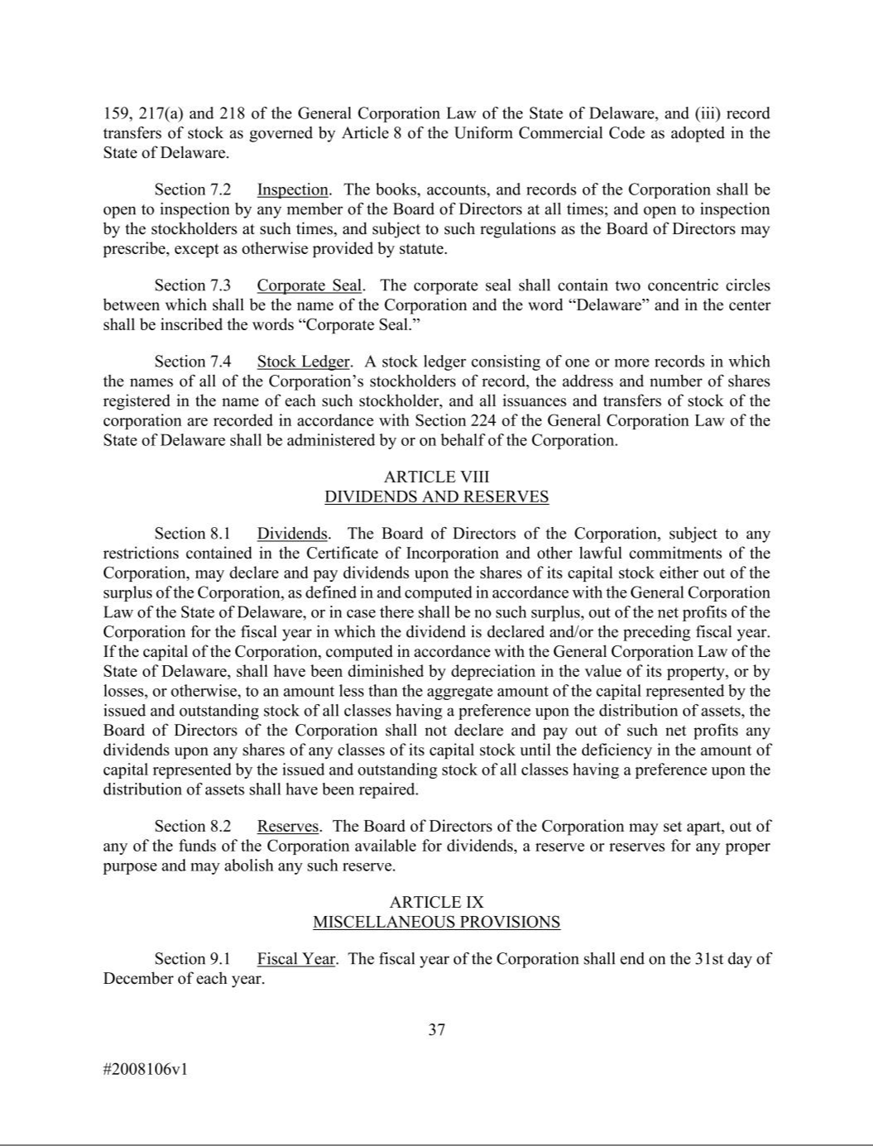

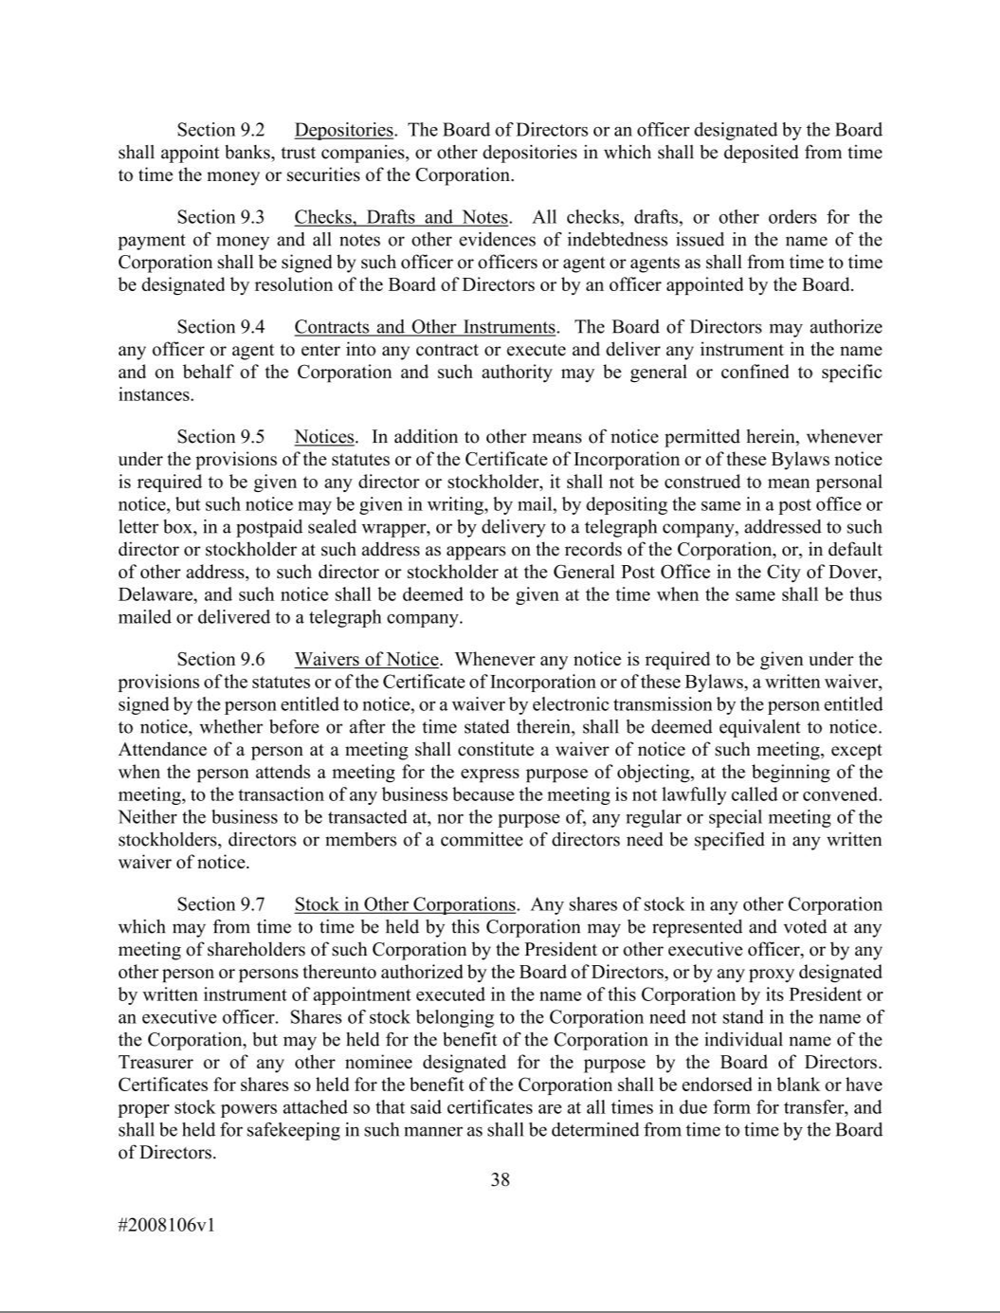

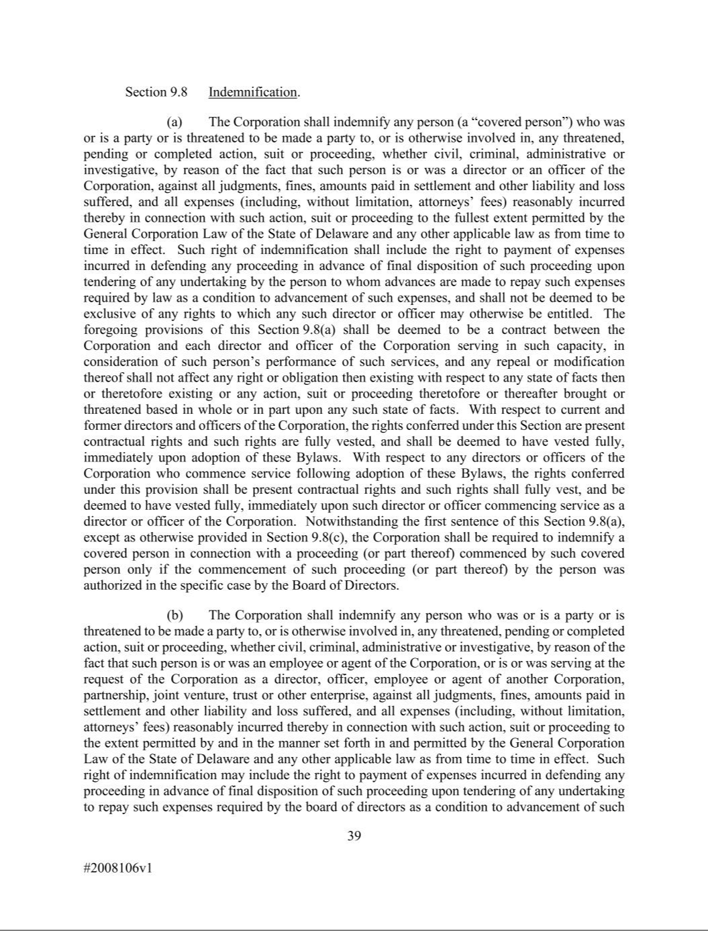

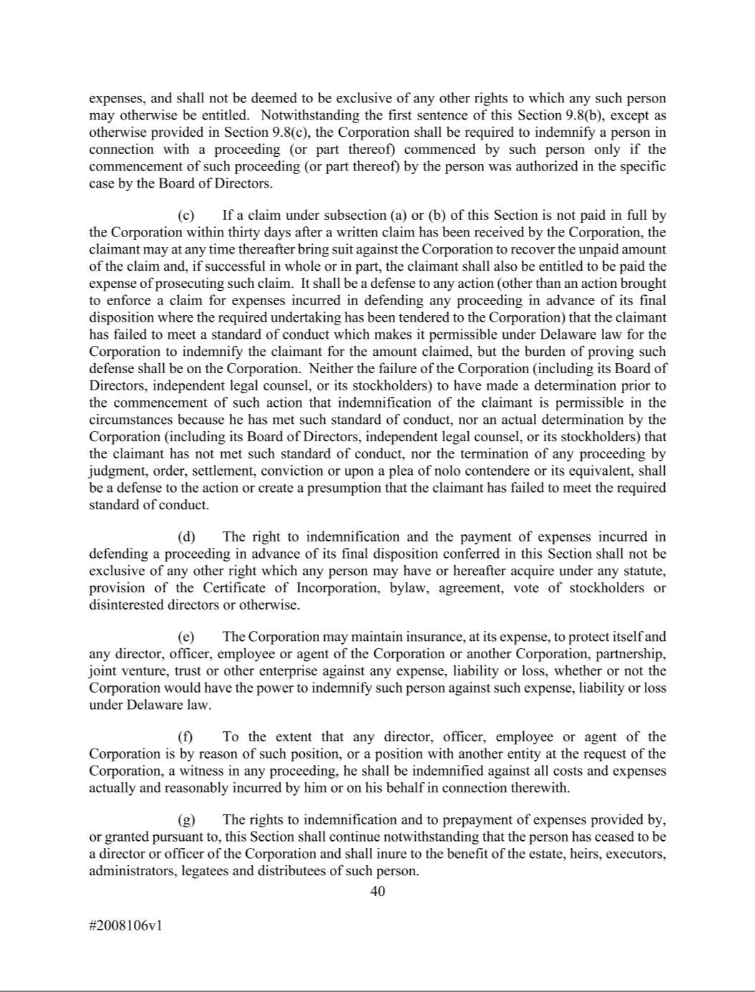

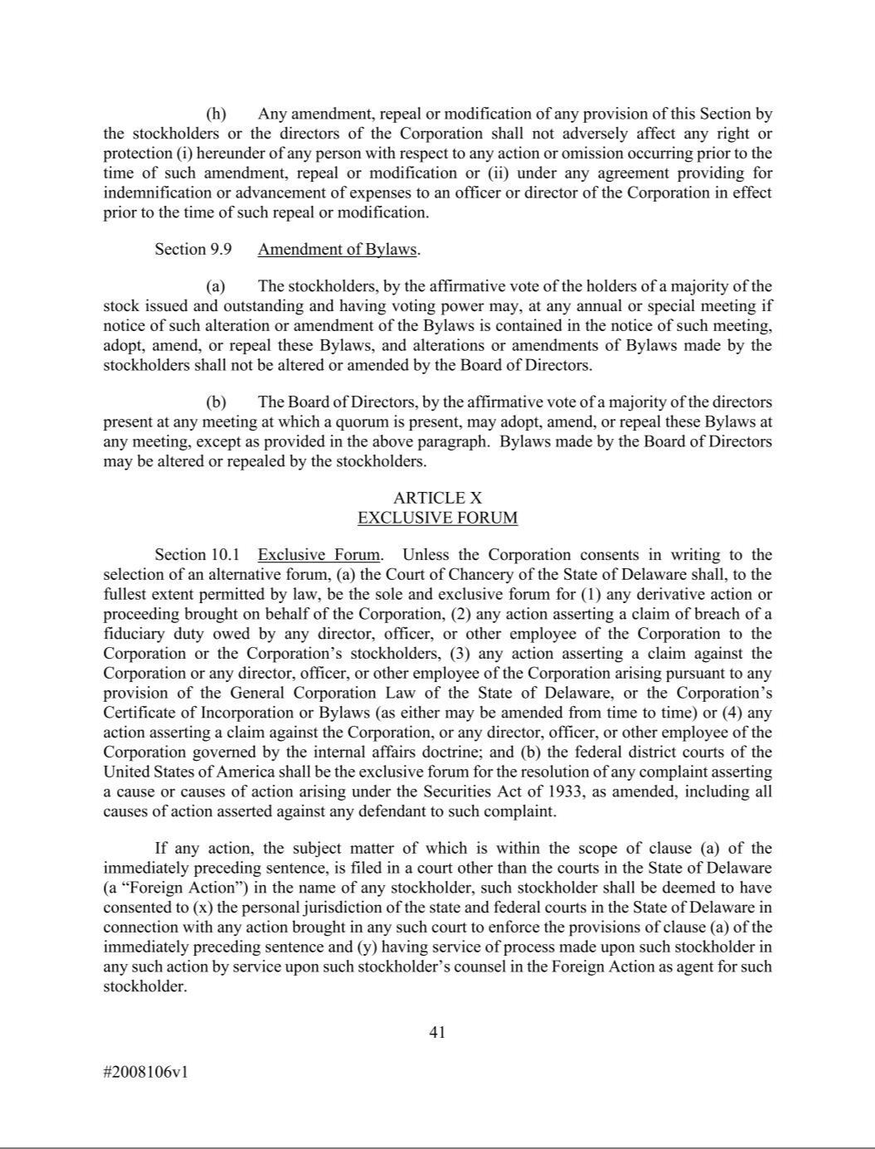



AMENDMENT NUMBER ONE TO THE

MOLINA HEALTHCARE, INC.

2025 EQUITY INCENTIVE PLAN

Molina Healthcare, Inc. adopts the following amendment to the Molina Healthcare, Inc. 2025 Equity Incentive Plan (the “Plan”), effective May 6, 2026.

Unless otherwise defined herein, any capitalized terms shall have the meaning set forth in the Plan.

1. Section 4.1 of the Plan is hereby amended and restated in its entirety as follows:

4.1 Maximum Number of Shares Issuable. Subject to adjustment as provided in Section 4.4, 3,295,000 shares of Stock shall initially be available for all Awards under the Plan, less one (1) share for every one (1) share granted under a Prior Plan after December 31, 2024. After April 30, 2025, no awards may be granted under a Prior Plan; however, any awards under a Prior Plan that are outstanding as of April 30, 2025 shall remain subject to the terms and conditions of, and continue to be governed by, such Prior Plan.

- Section 5.3(a)(i) of the Plan is hereby amended and restated in its entirety as follows:

  - Maximum Number of Shares Issuable Pursuant to Incentive Stock Options. Subject to adjustment as provided in Section 4.4, the maximum aggregate number of shares of Stock that may be issued under the Plan pursuant to the exercise of Incentive Stock Options shall not exceed 3,295,000. The maximum aggregate number of shares of Stock that may be issued under the Plan pursuant to all Awards other than Incentive Stock Options shall be the number of shares determined in accordance with Section 4.1.

- All other provisions of the Plan shall remain unchanged and in full force and effect.

IN WITNESS WHEREOF, the undersigned has caused this Amendment Number One to the Molina Healthcare, Inc. 2025 Equity Incentive Plan to be executed this 6th day of May, 2026.

MOLINA HEALTHCARE, INC.

By: /s/ Jeff D. Barlow

Name: Jeff D. Barlow

Title: Corporate Secretary

