As filed with the Securities and Exchange Commission on May 27, 2026

Registration No. 333-

UNITED STATES

SECURITIES AND EXCHANGE COMMISSION

Washington, D.C. 20549

FORM S-8

REGISTRATION STATEMENT

UNDER

THE SECURITIES ACT OF 1933

MOLINA HEALTHCARE, INC.

(Exact name of registrant as specified in its charter)

Delaware | 13-4204626
(State or other jurisdiction of | (I.R.S. Employer
incorporation or organization) | Identification No.)

200 Oceangate, Suite 100

Long Beach, California

(562) 435-3666

(Address, including zip code, of principal executive offices)

Molina Healthcare, Inc. 2025 Equity Incentive Plan

(Full title of the plan)

Jeff D. Barlow, Esq.

Chief Legal Officer
and Secretary

Molina Healthcare, Inc.
200 Oceangate, Suite 100
Long Beach, California 90802

(562) 435-3666
(Name, address and telephone number, including area code, of agent for service)

Copy to:

David Zaheer
Jenna B. Cooper
10250 Constellation Blvd., Suite 1100

Los Angeles, CA 90067
(424) 653-5500

Indicate by check mark whether the registrant is a large accelerated filer, an accelerated filer, a non-accelerated filer, a smaller reporting company, or an emerging growth company. See the definitions of “large accelerated filer,” “accelerated filer,” “smaller reporting company,” and “emerging growth company” in Rule 12b-2 of the Exchange Act.

Large Accelerated Filer

☒

Accelerated Filer ☐

Non-Accelerated Filer ☐

Smaller reporting company ☐

Emerging growth company ☐

If an emerging growth company, indicate by check mark if the registrant has elected not to use the extended transition period for complying with any new or revised financial accounting standards provided pursuant to Section 7(a)(2)(B) of the Securities Act. ☐

Explanatory Note

This Registration Statement on Form S-8 is being filed for the purpose of registering an additional 1,500,000 shares of common stock, par value $0.001 per share (the “Common Stock”), of Molina Healthcare, Inc. (the “Registrant”), reserved for issuance under the Registrant’s 2025 Equity Incentive Plan, as amended (the “2025 Plan”), pursuant to an amendment of the 2025 Plan that was approved by the Registrant’s stockholders on May 6, 2026. The additional shares registered pursuant to the 2025 Plan are of the same class as other securities relating to the 2025 Plan for which a Registration Statement on Form S-8 (No. 333-286908) is effective.

Pursuant to General Instruction E of Form S-8, the contents of the above-referenced prior registration statement are incorporated by reference herein to the extent not modified or superseded hereby or by any subsequently filed document, which is incorporated by reference herein or therein.

 |  |  |  |  |  |  |  |  |  |  |  | PART II
 |  |  |  |  |  |  |  |  | INFORMATION REQUIRED IN THE REGISTRATION STATEMENT
Item 8. Exhibits.
 | Exhibit Number |  |  |  |  |  |  |  |  |  |  | Description of Exhibit
 | 4.1 |  |  | Certificate of Incorporation (incorporated by reference to Exhibit 3.2 to the Registration Statement on Form S-1 filed with the Commission on December 30,
 |  |  |  | 2002).
4.2 |  |  |  | Certificate of Amendment to Certificate of Incorporation (incorporated by reference to Exhibit 3.2 to the Registrant’s Annual Report on Form 10-K filed with the
 |  |  |  | Commission on February 13, 2024).
4.3 |  |  |  | Certificate of Amendment to Certificate of Incorporation (incorporated by reference to Exhibit 3.3 to the Registrant’s Annual Report on Form 10-K filed with the
 |  |  |  | Commission on February 13, 2024).
4.4 |  |  |  | Certificate of Amendment to Certificate of Incorporation (incorporated by reference to Exhibit 3.1 to the Registrant's Current Report on Form 8-K filed with the
 |  |  |  | Commission on May 11, 2026).
4.5 |  |  |  | Amended and Restated Bylaws of the Registrant (incorporated by reference to Exhibit 3.2 to the Registrant’s Current Report on Form 8-K filed with the
 |  |  |  | Commission on May 11, 2026).
5.1* |  |  |  | Opinion of Latham & Watkins LLP.
23.1* |  |  |  | Consent of Ernst & Young LLP.
23.2* |  |  |  | Consent of Latham & Watkins LLP (included in Exhibit 5.1).
24.1* |  |  |  | Power of Attorney (included on signature page).
99.1 |  |  |  | Molina Healthcare, Inc. 2025 Equity Incentive Plan (incorporated by reference to Exhibit 10.1 to the Registrant’s Current Report on Form 8-K filed with the
 |  |  |  | Commission on May 1, 2025).
99.2 |  |  |  | Amendment Number One to the Molina Healthcare, Inc. 2025 Equity Incentive Plan (incorporated by reference to Exhibit 10.1 to the Registrant’s Current Report
 |  |  |  | on Form 8-K filed with the Commission on May 11, 2026).
107.1* |  |  |  | Filing Fee Table

*Filed herewith.

SIGNATURES

Pursuant to the requirements of the Securities Act of 1933, the Registrant certifies that it has reasonable grounds to believe that it meets all of the requirements for filing on Form S-8 and has duly caused this Registration Statement to be signed on its behalf by the undersigned, thereunto duly authorized, in the City of New York, State of New York on May 27, 2026.

MOLINA HEALTHCARE, INC.

By: /s/ Joseph M. Zubretsky

Joseph M. Zubretsky

Chief Executive Officer

(Principal Executive Officer)

SIGNATURES AND POWER OF ATTORNEY

Each person whose signature appears below hereby constitutes and appoints Joseph M. Zubretsky and Jeff D. Barlow, or each of them singly, with full power to act without the other, such person’s true and lawful attorneys-in-fact and agents, with full power of substitution and re-substitution, for him and in his name, place and stead, in any and all capacities, to sign this registration statement and any and all amendments, including post-effective amendments to this registration statement, and to file the same, with exhibits and schedules thereto, and other documents in connection therewith, with the Securities and Exchange Commission, granting unto said attorneys-in-fact and agents, and each of them, full power and authority to do and perform each and every act and thing requisite and necessary or desirable to be done in connection therewith as fully to all intents and purposes as he might or could do in person, hereby ratifying and confirming all that said attorneys-in-fact and agents, or any of them, or their or his substitute or substitutes may lawfully do or cause to be done by virtue hereof.

Pursuant to the requirements of the Securities Act of 1933, this registration statement has been signed by the following persons in the capacities and on the dates indicated.

Signature |  | Title |  | Date
/s/ Joseph M. Zubretsky |  | Chief Executive Officer and Director |  | May 27, 2026
Joseph M. Zubretsky |  | (Principal Executive Officer)
/s/ Mark L. Keim |  | Chief Financial Officer |  | May 27, 2026
Mark L. Keim |  | (Principal Financial Officer)
/s/ Maurice S. Hebert |  | Chief Accounting Officer |  | May 27, 2026
Maurice S. Hebert |  | (Principal Accounting Officer)
/s/ Barbara L. Brasier |  | Director |  | May 27, 2026
Barbara L. Brasier

/s/ Leo P. Grohowski | Director | May 27, 2026
Leo P. Grohowski
/s/ Stephen H. Lockhart | Director | May 27, 2026
Stephen H. Lockhart
/s/ Steven J. Orlando | Director | May 27, 2026
Steven J. Orlando
/s/ Ronna E. Romney | Director | May 27, 2026
Ronna E. Romney
/s/ Richard M. Schapiro | Director | May 27, 2026
Richard M. Schapiro
/s/ Francis S. Soistman | Director | May 27, 2026
Francis S. Soistman
/s/ Dale B. Wolf | Chairman of the Board | May 27, 2026
Dale B. Wolf
/s/ Richard C. Zoretic | Director | May 27, 2026
Richard C. Zoretic

Calculation of Filing Fee Tables

S-8

MOLINA HEALTHCARE, INC.

Table 1: Newly Registered Securities

 |  | Security |  | Security |  | Fee |  | Amount |  | Proposed |  | Maximum |  |  |  | Amount of
 |  | Security |  | Security |  | Calculation |  | Amount |  | Maximum Offering |  | Aggregate Offering |  | Fee Rate |  | Amount of
 |  | Type |  | Class Title |  | Calculation |  | Registered |  | Maximum Offering |  | Aggregate Offering |  | Fee Rate |  | Registration Fee
 |  |  |  |  |  | Rule |  |  |  | Price Per Unit |  | Price
 |  |  |  | Common
 |  |  |  | stock,
1 |  | Equity |  | $0.001 par |  | 457(a) |  | 1,500,000 |  | $ 178.97 |  | $ 268,455,000.00 |  | 0.0001381 |  | $ 37,073.64
 |  |  |  | value per
 |  |  |  | share
 |  |  |  |  |  | Total Offering Amounts: |  |  |  |  | $ 268,455,000.00 |  |  |  | $ 37,073.64
 |  |  |  |  |  | Total Fee Offsets: |  |  |  |  |  |  |  |  | $ 0.00
 |  |  |  |  |  |  | Net Fee Due: |  |  |  |  |  |  |  | $ 37,073.64

Offering Note

1

In accordance with Rule 416 under the Securities Act of 1933, as amended (the "Securities Act"), this Registration Statement shall be deemed to cover any additional securities that may from time to time be offered or issued under the Molina Healthcare, Inc. 2025 Equity Incentive Plan (as amended, the "2025 Plan") to prevent dilution resulting from stock splits, stock dividends or similar transactions. The Amount Registered consists of 1,500,000 shares of common stock, par value $0.001 per share ("Common Stock"), of Molina Healthcare, Inc. (the "Registrant") available for issuance under the 2025 Plan pursuant to an amendment of the 2025 Plan that was approved by the Registrant's stockholders on May 6, 2026. The Proposed Maximum Offering Price Per Unit is estimated solely for purposes of computing the registration fee pursuant to Rules 457(c) and 457(h) of the Securities Act, and is based upon the average of the high and low prices of the shares of Common Stock, as reported on The New York Stock Exchange on May 21, 2026, which date is within five business days prior to the filing of this Registration Statement.

Table 2: Fee Offset Claims and Sources |  |  |  |  |  |  |  |  | ☑Not Applicable
 |  |  |  |  |  |  |  |  | Unsold
 |  |  |  |  |  | Security | Security | Unsold | Aggregate | Fee
 | Form |  | Initial |  | Fee | Type | Title | Securities | Offering | Paid
Registrant or Filer | or | File | Initial | Filing | Fee | Associated Associated Associated |  |  | Amount | with
Name | Filing | Number | Filing | Date | Offset | with Fee | with Fee | with Fee | Associated | Fee
 | Type |  | Date |  | Claimed | Offset | Offset | Offset | with Fee | Offset
 |  |  |  |  |  | Claimed | Claimed | Claimed | Offset | Source

Claimed

Rule 457(p)

Fee Offset

Claims

Fee Offset

Sources

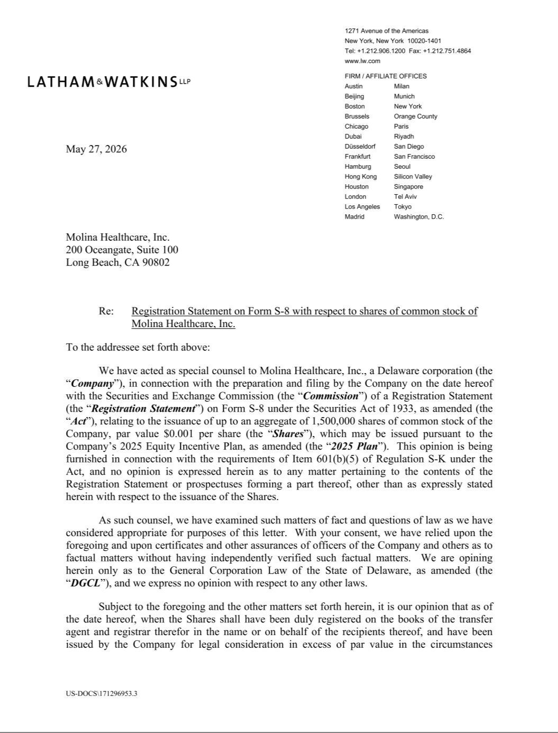

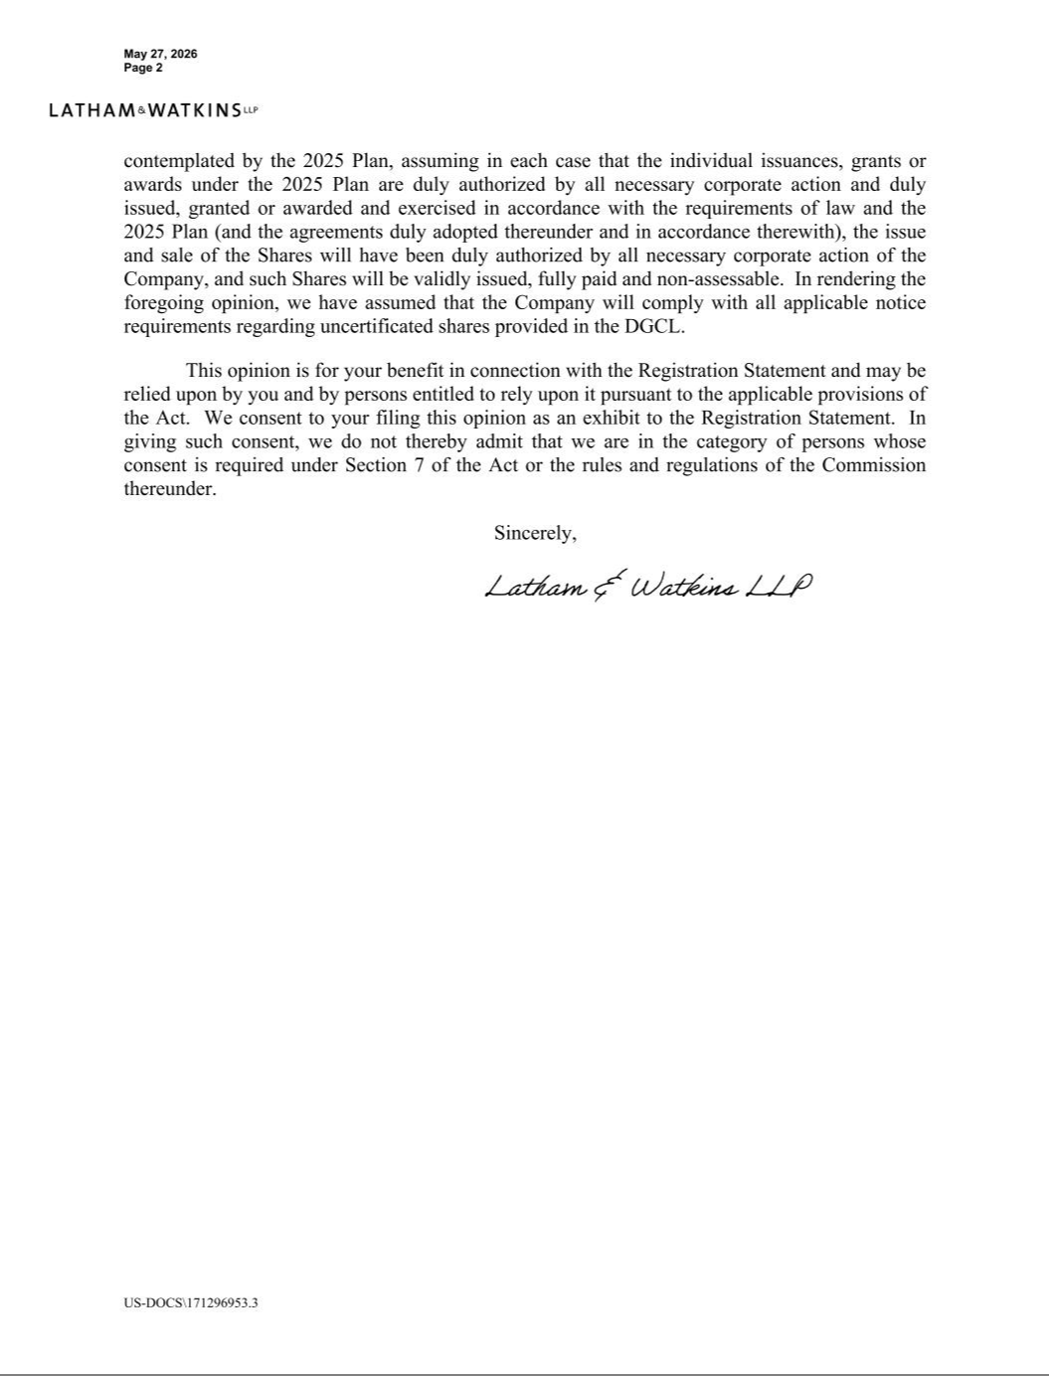

Exhibit 23.1

Consent of Independent Registered Public Accounting Firm

We consent to the incorporation by reference in the Registration Statement (Form S-8) pertaining to the Molina Healthcare, Inc. 2025 Equity Incentive Plan of our reports dated February 10, 2026, with respect to the consolidated financial statements of Molina Healthcare, Inc. and the effectiveness of internal control over financial reporting of Molina Healthcare, Inc. included in its Annual Report (Form 10-K) for the year ended December 31, 2025, filed with the Securities and Exchange Commission.

/s/ Ernst & Young LLP

Los Angeles, California

May 27, 2026

